Using Chronolator Documents
Version 3.3

A guide to Chronolator tools and features

Chronolator © 2004 - 2014 Berrick Computing Ltd
www.chronolator.co.uk

Microsoft Word © Microsoft Corporation
Contents
1 Introduction 9
1.1 What is Chronolator and what does it do? 9
1.1.1 Administrators 9
1.1.2 Front-line staff 9
1.1.3 Reviewers 9
1.1.4 The Chronolator Process 10
1.2 About this document 13
1.3 Chronolator Documentation 13
1.4 A note about Word versions and options 13
1.4.1 Limited support for Word 2000 13
1.4.2 Word for Apple Mac 13
1.4.3 How can I tell which version of Word I am using? 14
1.5 Viewing and printing this document 15
1.5.1 Conventions and Symbols 15
1.5.2 Online viewing 15
1.5.3 Printing 17
2 Opening a Chronolator Document 18
2.1 Microsoft Word macros 18
2.1.1 Enabling Macros 18
2.2 Licensing 23
2.3 Chronolator toolbars 23
2.4 The Internal Chronology toolbar 24
3 Chronolator features - a summary 25
3.1 Entering and checking events in a Chronolator Document 25
3.2 Producing Composite Chronologies 25
3.3 Advanced Features and Productivity Tools 25
3.4 Practise using Chronolator 25
3.5 Getting Help 25
4 Entering and checking events in a Chronolator Document 26
4.1 Entering data in the Chronology Table 26
4.2 Special columns 27
4.2.1 Event order: Date, Time and Sequence columns 27
4.2.2 Source of Information column 28
4.2.3 Glossary column 28
4.2.4 Mandatory columns 28
4.2.5 Finding what special columns are included 29
4.3 Checking data 30
4.3.1 Correcting errors 31
4.3.2 The Sort Tables button 35
5 Creating a Composite Chronology document 37
5.1 Administrators 37
5.2 Overview 37
5.3 Step by Step Guide 38
5.3.1 Make a blank Composite Chronology document 38
5.3.2 Identify the Composite Chronology Toolbar 39
5.3.3 Import Chronology Documents into the Composite Chronology 39
5.3.4 Merge tables in a Composite Chronology 40
5.3.5 Format Dates 41
5.3.6 Sort a Chronology 41
5.3.7 Final checks 42
5.3.8 Publishing a chronology document 42
6 Advanced Features and Productivity Tools 43
6.1 The Age and Interval Calculator 43
6.1.1 Awkward calendars 44
6.1.2 Easy calculations 44
6.1.3 Slightly harder calculations 45
6.1.4 Difficult calculations 45
6.1.5 The Chronolator solution 46
6.2 Working with Duplicated Rows 46
6.2.1 How duplicated rows can occur 46
6.2.2 Highlight or Delete? 47
6.2.3 Ignoring the Source of Information when identifying duplicates 47
6.2.4 Examples 47
6.3 Working with the Abbreviations Glossary 50
6.3.1 Viewing and printing abbreviations 50
6.3.2 Adding an abbreviation 51
6.3.3 Changing an abbreviation 52
6.3.4 Browsing a document using the Abbreviations Glossary 54
6.4 Anonymisation and Personalisation 55
6.4.1 Warning 55
6.4.2 Switching between Anonymised and Personalised views of a document 56
6.4.3 Reviewing and changing how entries in the Abbreviations Glossary appear in the text 56
6.4.4 Producing an extract of events containing selected Glossary entries 58
6.5 Using a Sequence column 59
6.5.1 Defining a Sequence Column 59
6.5.2 Changing the Sequence Column Heading 59
6.5.3 Giving events a Reference Number 60
6.5.4 Forcing events into order 61
6.5.5 Sequence column conflicts when Importing a chronology 63
6.6 Highlighting Sources of Information 64
6.6.1 Scope 64
6.6.2 Colour Scheme 65
6.6.3 Custom Settings 66
6.6.4 Previewing and Doing 66
6.6.5 Using highlights to get an overall picture of an agency’s involvement 66
6.7 Publishing a chronology 67
6.7.1 Exact Copy 67
6.7.2 Narrative formats 67
6.8 Add-ins 71
6.8.1 Loading an add-in 71
6.8.2 Using an add-in 72
6.9 Document Details and System Information Reports 73
6.9.1 The Document Details report 73
6.9.2 The System Information report 78
7 Hidden macros 79
7.1 Importing a document without adding a Source Prefix 80
7.2 Cleaning up the Chronolator environment 80
7.3 Unloading Chronolator Add-ins 80
8 Working with Microsoft Word tables 81
8.1 Terminology 81
8.2 Using a mouse 81
8.3 Selecting items in a table 81
8.3.1 Selecting items with the mouse 81
8.3.2 Selecting items with the keyboard 82
8.4 Adding rows to a table 82
8.5 Copying and Moving items in a table 83
8.5.1 Copying and moving items with the mouse 83
8.5.2 Copying and moving items with the keyboard 83
8.5.3 Undoing mistakes 83
Appendix A – Troubleshooting 84
The Chronolator toolbar does not appear 84
Security settings 84
Expired Licence 94
The Chronolator toolbar has disappeared 95
The Chronolator toolbar doesn’t have all its buttons 95
The Chronolator progress bar disappears 96
Recovering corrupted Chronolator Documents 96
Run-time Errors 96
Corrupted tables or text, or Word stops working 98
Slow processing 99
Conflicts with other Word add-ins 99
Starting Word without loading any add-ins 99
Appendix B – Chronolator messages 102
Message Form Messages 102
The Message Form 102
Messages 1000 – 1999 103
Messages 2000 – 2999 110
Messages 3000 – 3999 113
Messages 4000 – 4999 120
Messages 5000 – 5999 122
Messages 6000 - 6999 133
Messages 7000 - 7999 134
Messages 8000 - 8999 136
Check Table Error Codes 137
Appendix C – Licensing 140
Online Workbench Licence 140
Chronolator Document Licence 140
Licence Period 140
What happens when a licence expires 141
Temporary Licence Extension 141
‘Refreshing’ an expired licence 141
Appendix D - How Chronolator deals with events with imprecise dates or times 142
Assumptions 142
Individual events 142
Durations 142
Assumed information is never displayed 142
Overriding Chronolator’s assumptions 142
Appendix E - Chronolator Terminology 143

Figures

Figure 1 - multiple levels of administration - schematic document flow 11
Figure 2 - multiple levels of administration - a possible scenario 12
Figure 3 - faulty Chronology Table before checking 31
Figure 4 - faulty Chronology Table after checking 32
Figure 5 - mouse pointer shapes 81

Introduction

What is Chronolator and what does it do?
Chronolator makes it easy to produce the chronologies that are needed to review interactions between different agencies and organisations. Since it is based on Microsoft Word, little specialist knowledge is required to use it. There are no new programs to learn or install, and only a basic knowledge of working with Word tables is required.
Chronolator has something to help everyone involved in using a chronology to investigate a case:
- those who supervise and administer it;
- the front-line staff who input the data;
- those who review it.

Administrators
Gathering and collating chronologies from multiple agencies is a time consuming task, particularly if they each have different ideas about what they need to provide. Chronolator enforces the standards set by the administrator (for example, what column headings the chronology table should have) and automates the merging of individual chronologies.

Front-line staff
Transcribing written records from various sources into a consistent format is a tedious and error-prone task. Chronolator simplifies the process with a number of tools. There are tools to sort records into order, to put dates into consistent formats, and to check for a variety of problems.

Reviewers
The final objective of a chronology is that someone can make sense of the events it contains. Chronologies are often anonymised, which can make it difficult to build a mental picture of the people involved. The Chronolator anonymisation tool lets you switch back and forth between anonymised and personalised views of a document.
Other tools for reviewers include:
- reports about individuals identified in the Abbreviations Glossary;
- colour-coding events according to the agency reporting them;
- a calculator to work out the interval between two dates;
- formatting a tabular chronology into a narrative layout.

The Chronolator Process
The Chronolator process begins when the Case Review Administrator sets up an Internal Chronology, which is a Word document containing a table whose headings and other characteristics are specified by the Administrator.
The Case Review Administrator distributes the Internal Chronology to the various organisations whose data is required.
If an organisation needs to collect data from several departments, the recipient can forward the Internal Chronology to them and ask them to complete it rather than calling for their original records. Anyone forwarding a document in this way is called a Local Administrator.
When the holders of the original records have completed their documents, they return them to the Administrator who wanted the information (either the Case Review Administrator or a Local Administrator). That Administrator uses Chronolator to merge them into a Composite Chronology.
There is no limit to the number of levels of Local Administration.
The diagrams below (Figure 1 on page 11 and in Figure 2 on page 12) illustrate the flow of documents between administrators and data collectors.
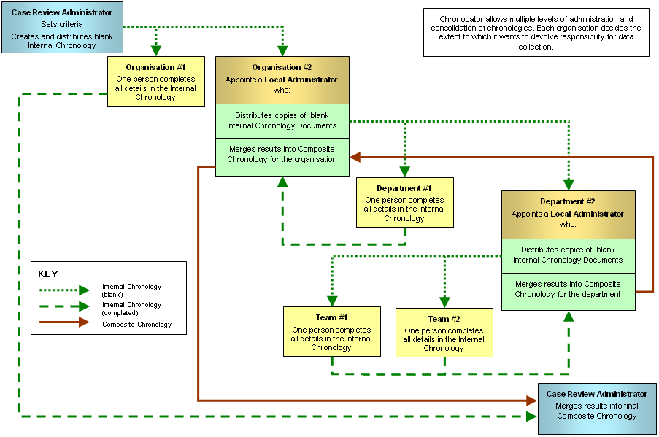
Figure 1 - multiple levels of administration - schematic document flow
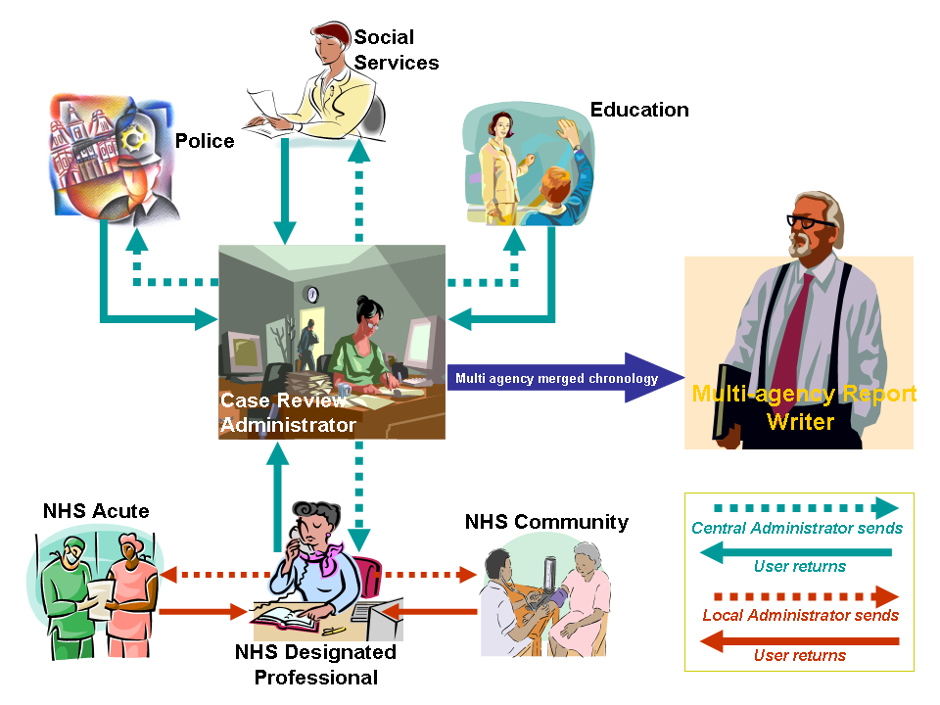
Figure 2 - multiple levels of administration - a possible scenario

About this document
This document describes the Chronolator tools that help to complete, merge, format, and review chronology tables.
It also contains some hints and tips about using Word tables in general, and a complete list of Chronolator messages.
For information about the terminology used in this document (such as ‘Internal Chronology’ and ‘Local Administrator’), see Appendix E - Chronolator Terminology on page 143.

Chronolator Documentation
Setting Up Chronolator Documents describes how to create Chronolator Documents using the Chronolator Online Workbench, and how to distribute them.
Using Chronolator Documents (this document) describes how Chronolator facilitates the production of accurate chronologies, how to combine Chronolator Documents into Composite Chronologies, and the other tools and features Chronolator provides.
Using Chronolator Samples contains some exercises you can undertake with the sample documents to acquaint yourself with the main features of Chronolator.

A note about Word versions and options
The illustrations in this document were mostly taken using Word 2013 with a typical set of user options; your own experience might be slightly different. Separate instructions are provided for each Word version if there are marked differences.
Chronolator documents are supplied in the docm format introduced with Word 2007. They can be opened in Word XP and 2003 if the Microsoft Office Compatibility Pack is installed. They can be saved in the old doc format if need be.

Limited support for Word 2000
Word 2000 is no longer supported by Microsoft. Macros in docm files are not supported in Word 2000 even if the Compatibility Pack is installed. Word 2000 is therefore not suitable if you want to use the Chronolator Online Workbench.
If you are using Word 2000 and your administrator has sent you an Internal Chronology as a docm file, ask them to save and send you a doc version.

Word for Apple Mac
Chronolator is designed for and tested on Windows versions of Word. It will certainly not work with Word 2008 for Mac, as it does not include the Visual Basic for Applications programming environment used to run macros. It might run OK on other versions of Word for Mac, but it is not tested on them and support is not guaranteed.

How can I tell which version of Word I am using?
The simplest way is to look at the 'splash screen' Word displays while it starts.
Word XP | Word 2003 | Word 2007 | Word 2010 | Word 2013
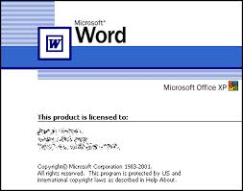 | 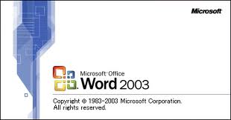 | 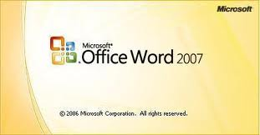 | 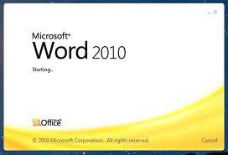 | 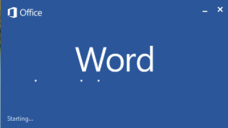

Alternatively, type 'how can I tell which version of Word I am using' into a search engine. At the time of writing, the most useful link this revealed was on Microsoft's web site:
http://office.microsoft.com/en-gb/word-help/what-version-of-office-am-i-using-HA101873769.aspx.

Viewing and printing this document

Conventions and Symbols
Text like this generally denotes something on the screen that you can press.
Text like this denotes a reference to a tool or function, or is used for general emphasis.
Text like this refers to a document.
Hyperlinks to other places in the document, or to other documents, are displayed like this.
This symbol marks a hint or tip.
This one marks a Warning.

Online viewing
This document is available in Word and PDF versions.
We recommend the Word version for online reading. Use the Web Layout and Navigation Pane options on the View tab to avoid unnecessary page and table breaks and give you an overview of the document headings. Clicking on one of the headings in the Navigation Pane takes you to the relevant part of the document.
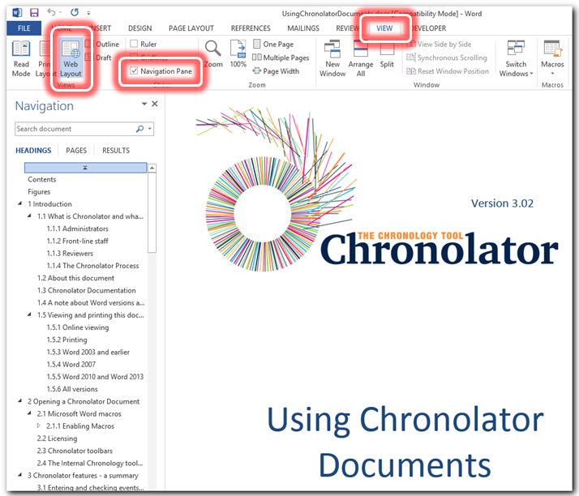

Hyperlinks
The document also contains hyperlinks, which are displayed like this. Click on one to go to the relevant part of the document.
We recommend that you add the Back button to the Quick Access Toolbar (QAT) on the ribbon so that you can go back to where you came from. Follow the instructions below to see how to do this.
Press the small arrow to the right of the QAT, and click on More Commands . . . | 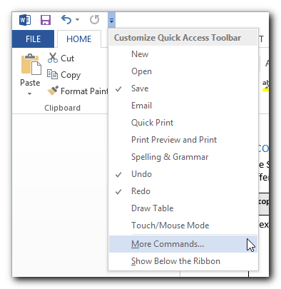
Under Choose Commands From , select Commands Not in the Ribbon.  Scroll down to Back.  Press Add >>.  Press OK. | 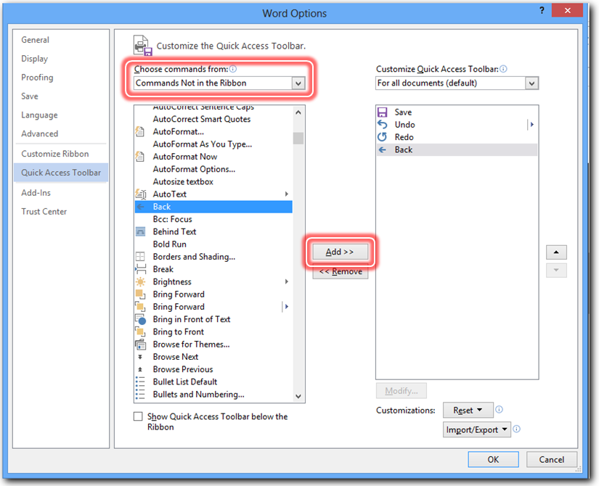
The Back button is added to the QAT: | 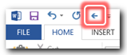

Now, after you have followed a hyperlink, you can use the button to go back to where it occurred.

Printing
For printing we recommend the PDF version of this document as it avoids any issues with page numbering.
If you nevertheless want to print the Word version, note that Word resolves page references ‘on the fly’. To make sure they are correct when you print it, ensure that the relevant Word option is turned on as described below.

Word 2003 and earlier
Press Tools > Options > Print and tick the Update Fields box.

Word 2007
Press > > Word Options > Display and tick the Update fields before printing box.

Word 2010 and Word 2013
Press File > Options > Display and tick the Update fields before printing box.

All versions
If you get a message like this, select Update Entire table and press OK. | 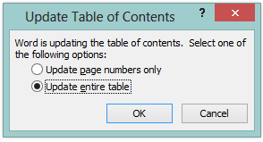

Opening a Chronolator Document
Chronolator Documents are Microsoft Word documents with extra features. All standard Word features are available and work in the usual way.
If you receive a Chronolator Document as an email attachment, you should save it somewhere on your system and work on the saved copy. This avoids the loss of work which can arise from working directly on any email attachment.

Microsoft Word macros
Chronolator works by using Word ‘macros’. Because they are computer programs, macros can be used to propagate and run computer viruses. Word therefore allows you to prevent them running, since for most documents they are unnecessary. However, for Chronolator they are essential.
When macros are allowed to run, Chronolator will ask you to confirm that you accept its licence terms. In that case, continue reading at Licensing on page 23. | 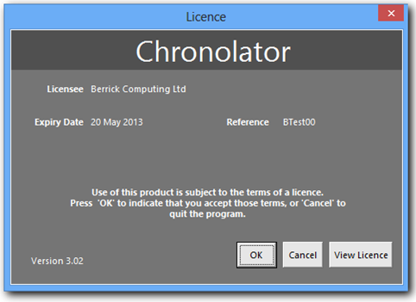
If the licence screen does not appear, you will need to ensure macros can run. The following section Enabling Macros shows you how.

Enabling Macros
Following the instructions given here will ensure that Chronolator can run without compromising your computer.

Word 2003 and earlier versions
Word 2003 and earlier versions display messages about macros as they open the document. For example, they might display a message like one of these:
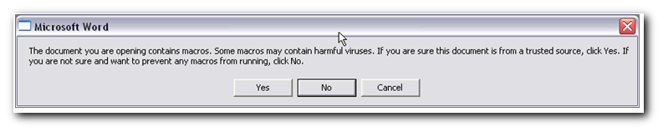 | Press Yes.  Continue reading at Licensing on page 23.

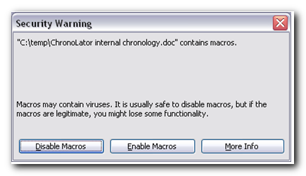 | Press Enable Macros.  Continue reading at Licensing on page 23.

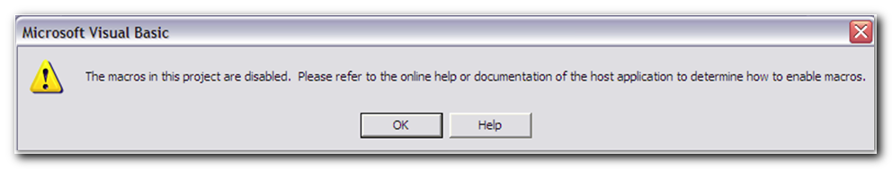 | Press OK and then refer to Word 2003 and earlier versions on page 87.

Word 2007 and later versions
Sometimes (usually if another document is already open) the later versions of Word will display a message like this when you open a document containing macros:  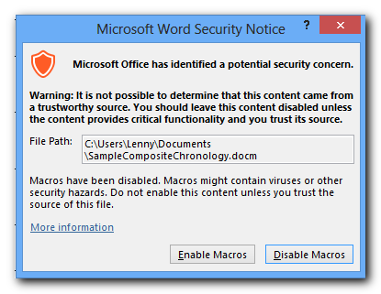 | Press Enable Macros.  Continue reading at Licensing on page 23.
However, these later versions sometimes do not tell you that a document contains macros until after they have opened it - and if your security settings are overly restrictive they might even disable them without telling you they are there!
- If you are using Word 2007, see Word 2007 below;
- If you are using Word 2010 or 2013, see Word 2010 and Word 2013 on page 20.

Word 2007
The following pictures show what you might see after Word 2007 has opened the document.

In this illustration, Word 2007 informs you it has disabled macros by displaying a message under the Ribbon.  If you see such a message, refer to Word 2007 displays ‘Security Warning Macros have been disabled’ on page 92. | 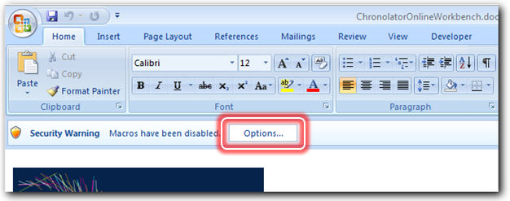
Here, the area between the Ribbon and the document is blank.  If there is no Add-Ins tab on the Ribbon, Word has probably disabled macros without telling you.  If so, see Word 2007 or later versions do not display any warning about macros on page 89. | 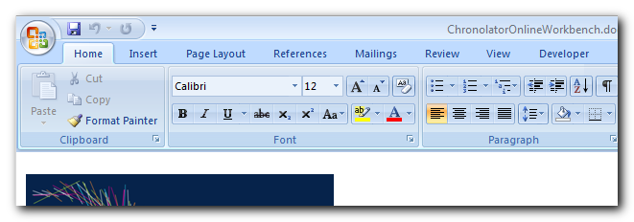

Word 2010 and Word 2013
Word 2010 introduced another level of security called ‘Protected View’ that a document must pass even before it is checked for macros. Protected View continues to work in the same way in Word 2013.
Because this additional security can become tedious, Word 2010 and 2013 remember the choices you make. Once you have allowed a particular document to be opened with macros enabled, they will usually open in future without question.
The next few paragraphs deal first with Protected View, and then with Enabling Macros. The pictures are from Word 2013, but what you need to do is the same for both versions.

Protected View – ‘Enable Editing’
Word might open a document in Protected View for a variety of reasons, and it is only possible to cover some common scenarios here. If you need more information, search Word’s Help for ‘Protected View’ and read the article entitled What is Protected View?

If you get a warning like this, press Enable Editing. | 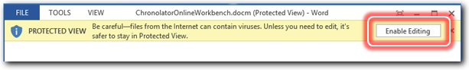
If editing is prevented as shown here, see Protected View (Word 2010 and Word 2013) on page 84. | 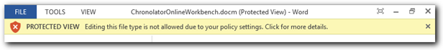

Enabling macros – ‘Enable Content’
When it comes to macros, Word 2010 and 2013 are similar to Word 2007 in two respects:
- they do not tell you that a document contains macros until they have opened it;
- if your security settings are overly restrictive they might disable macros without telling you they are there.
In this illustration, Word 2013 informs you it has disabled macros by displaying a message under the Ribbon.  Press Enable Content to enable them. | 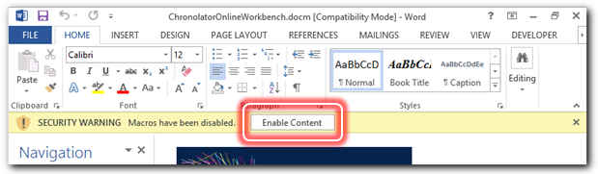
Here, the area between the Ribbon and the document is blank.  If there is no Add-Ins tab on the Ribbon, Word has probably disabled macros without telling you.  If so, see Word 2007 or later versions do not display any warning about macros on page 89. | 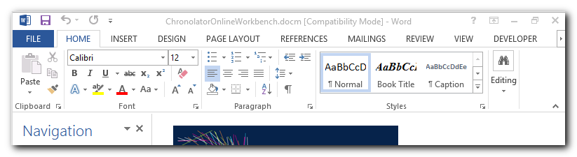

You can find more information about setting up Microsoft Word macro security in Security Settings on page 84, or you might like to view one of the video tutorials about “Running Macros” at www.chronolator.co.uk/tutorials.

Licensing
Chronolator is licensed software. If macros have been properly enabled, a Licence screen is displayed when you open the Online Workbench or a Chronolator Document:

Press OK to continue using Chronolator.
Press Cancel if you do not agree to the licence terms. The document will close.
Press View Licence if you want to read the licence terms.
Further details about licensing can be found in Appendix C on page 140.

Chronolator toolbars
After you accept the licence terms, Chronolator creates a new Toolbar. Depending on the type of document, the contents of the toolbar may vary. The pictures below are of the toolbar in an Internal Chronology.
In Word 2007 and later versions, the Chronolator toolbar is added to any other custom toolbars on the Ribbon’s Add-Ins tab. | 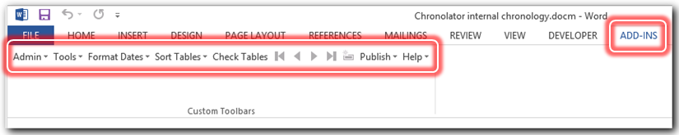
In Word 2003 and earlier versions, the Chronolator toolbar is added below your other toolbars | 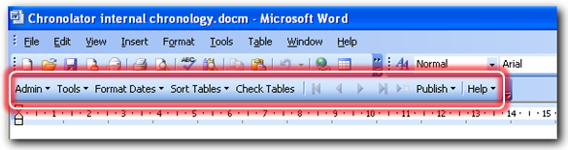

If the toolbar does not appear, see The Chronolator toolbar does not appear on page 84.

The Internal Chronology toolbar
The Internal Chronology toolbar provides a number of features to simplify the production of an accurate chronology which can easily be merged with others. These features are described in detail later on, but here is a summary of what they do:
The Admin menu has buttons for various administrative tasks, such as:
  - viewing internal information about the document;
  - creating a Composite Chronology containing chronologies from different departments and organisations.
The Tools menu helps you:
  - calculate the interval between two dates;
  - anonymise and re-personalise a document;
  - find duplicated rows;
  - highlight events according to the agency that reported them;
  - add reference numbers to a chronology, and specify the order of events on a day when their exact times are unknown;
  - use Chronolator Add-ins to provide added functions.
The Format Dates menu changes dates and times to a consistent format, including options to include the day of the week.
The Sort Tables menu sorts the rows of a table into ascending or descending date and time order.
The Check Tables button checks the data in a document on demand (Chronolator also checks it when you close the document).
The buttons navigate from one error to the next.
The Publish menu creates an exact copy of the document without any Chronolator macros. It also allows you to produce the chronology table in a number of narrative formats.
The Help menu displays the Chronolator version and has links to some video tutorials.

Chronolator features - a summary

Entering and checking events in a Chronolator Document
Chronolator aims to make it as easy as possible to transcribe paper and other records into chronology tables. For example:
- you can enter records as they become available and sort them later;
- you can type in dates just as they are written, and let Chronolator put them in a consistent format;
- Chronolator checks that the events in a chronology table are in order and that what is entered fits the criteria set by the Case Review Administrator.
These data entry and checking features are described in Entering and checking events in a Chronolator Document on page 26.

Producing Composite Chronologies
Information is often needed from a number of different departments within an organisation. Chronolator speeds the process of getting this information by letting you forward an Internal Chronology to other people for them to complete. When they return their completed copies, you use Chronolator to combine them into a Composite Chronology.
Creating Composite Chronologies is described in Creating a Composite Chronology document on page 37.

Advanced Features and Productivity Tools
Chronolator provides a number of other tools to facilitate working with chronologies. These are described in Advanced Features and Productivity Tools on page 43.

Practise using Chronolator
If you want to practise using Chronolator you can use the sample files supplied with it alongside the Using Chronolator Samples document. If you do not have these you can download them from www.chronolator.co.uk.

Getting Help
Chronolator provides a number of video tutorials which illustrate how to accomplish many of the tasks you need to undertake. Press Help > Tutorials on the Chronolator toolbar to see them. If they are not installed on your computer, you will be asked if you want to view them on the Web.

Entering and checking events in a Chronolator Document
A Chronolator Document consists of an optional preamble and one or more Chronology Tables:
- the Case Review Administrator can include a preamble containing details of the case and a brief description of how to use Chronolator;
- the Chronology Table is where you enter details about the case under review.
Chronolator ignores the document preamble, processing only the Chronology Table(s).
If you receive a Chronolator Document as an email attachment, you should save it somewhere on your system and work on the saved copy. This avoids the loss of work which can arise from working directly on any email attachment.

Entering data in the Chronology Table
Entering data into a Chronology Table requires a basic knowledge of working with Word tables – how to create a new row, how to move a row and so on. If you are unfamiliar with these ideas, you will find some hints and tips in Working with Microsoft Word tables on page 81.
When a Chronolator Document is created, the Case Review Administrator specifies the rules which must be followed in the Chronology Table – for example, what the column headings are and which columns must always be completed. The Administrator should tell you what these rules are, either in the document preamble or in a covering letter. Chronolator checks that the data you enter conforms to these rules every time you close the document, and warns you if it finds any problems. You should correct any errors before returning the document.
It is essential that you do not change, add or remove any headings in the Chronology Table, as Chronolator relies on them to check the data you enter. You can change the font, the column widths, the shading and so on, but you must not change the heading text or add or remove columns.
If you accidentally change the headings and forget what they should be, you can generate a new set at the end of the document by pressing the Admin > New Table button on the Chronolator toolbar. After doing this, either copy any data you have already entered into the new table, or copy the heading row from the new table into that of the old one.

Special columns
Chronolator treats most of the columns in a chronology table as free-form text, only checking them if the Case Review Administrator has deemed them mandatory. However, some columns play a major role in the way a Chronolator Document is processed.
These special columns are briefly described below.
Chronolator's names for them are shown like this, but the Case Review Administrator can give them different headings in the actual chronology table.

Event order: Date, Time and Sequence columns
Up to five special columns can be used to specify when an event happened:
- Sequence (optional)
- Start Date (mandatory for all Chronolator Documents)
- Start Time (optional)
- End Date (optional)
- End Time (optional)
Chronolator can populate the Sequence column with event reference numbers. It can also be used to specify the order of events on a particular day when you do not know their times. If you need to do this and the Administrator has not included one, you can add a Sequence column using the Tools > Sequencing > Add column button. (This is the only change Chronolator allows to Administrator-defined column headings).

Dates
Chronolator allows you to enter dates in many formats. For example, all the following will be recognised:
- 22.05.04
- 22-may-04
- 22/05/04
- 22/05/2004
Chronolator expects a Date column to contain a single date and no other words or characters. For example ‘? 22 may 2004’ or ‘probably 22 may 2004’ would not be allowed.
If you are unsure of the exact date of an event, enter your best estimate and note that you have done so in one of the other columns. Similarly, if you want to enter a range of dates and the Case Review Administrator has not included an End Date column, enter the first date in the Start Date column and the other date in one of the other columns.
The Format Dates menu on the Chronolator toolbar lets you set all the dates you have entered into a consistent format.

Times
Chronolator is also flexible about the formats used in any Time columns in the table. For example, the following will all be recognised:
- 0100
- 01.00
- 01:00
- 1 am
- 01 am
The Format Dates menu on the Chronolator toolbar also puts all the times you have entered into a consistent format; all the above would become ’01:00’.

Source of Information column
After the Event Order columns comes the Source of Information column, where you specify the source of your information about the event.
When entering the source of your information, do not include your own organisation or department. This information will be added by the Administrator who sent you the document.
For example, suppose you work at the Berrick New Town Clinic and are entering data you have obtained from a Health Visitor’s notes. You should record the source of information simply as, say, HV notes, not as Berrick New Town Clinic HV notes. The administrator who sent you the document will add ‘Berrick New Town Clinic’ when using Chronolator to combine documents. (You can see an example of this in Specify where the document came from on page 40).

Glossary column
A Glossary column can be included which should contain only abbreviations that have been defined in the Abbreviations Glossary - for example, somebody's initials. This can be useful when a chronology contains information pertaining to more than one person. Chronolator will check that anything in this column has been defined in the Abbreviations Glossary.
You can view the glossary and add your own abbreviations to it by pressing the Admin > Abbreviations button on the Chronolator toolbar. Each abbreviation can be up to ten characters long, and its definition up to thirty.
You can anonymise and personalise a document by using the Abbreviations Glossary in conjunction with the Tools > Anonymisation button.

Mandatory columns
Chronolator insists that the Start Date and Source of Information columns must always be completed. The Case Review Administrator decides what other columns are mandatory.

Finding what special columns are included
The Admin > Show Document Details button on the Chronolator toolbar displays a summary of what special columns and abbreviations the Case Review Administrator has set up.
It will usually be obvious from the column headings what type of data is expected. If not, ask the person who sent you the document to explain them.

Checking data
Chronolator checks your Internal Chronology document every time you close it. If it finds errors, it displays this message.  Press Cancel to keep the document open so you can correct the errors.  Press OK if you want to correct them later. The document will close. | 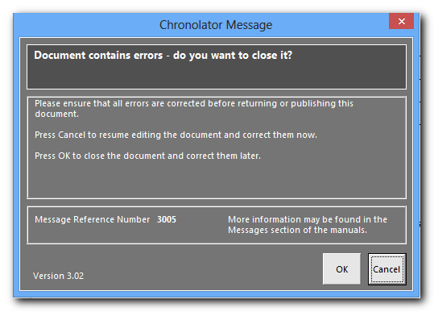
You can also check the document whenever you want by pressing the Check Tables button on the Chronolator toolbar:  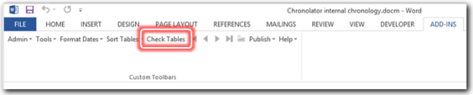  If the document is error-free it will tell you. | 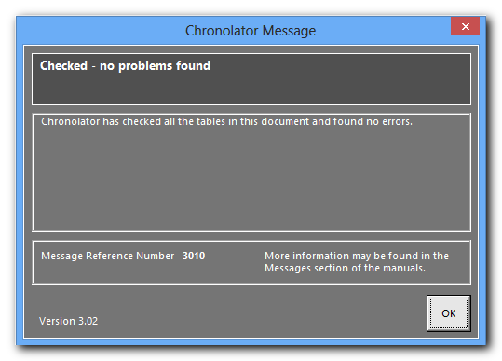
If the document contains errors, this message is displayed. The number in brackets says how many errors were found.  Like all Chronolator messages, it has some suggestions about what you might do next. In this case, the message describes how you can find out more about the errors. | 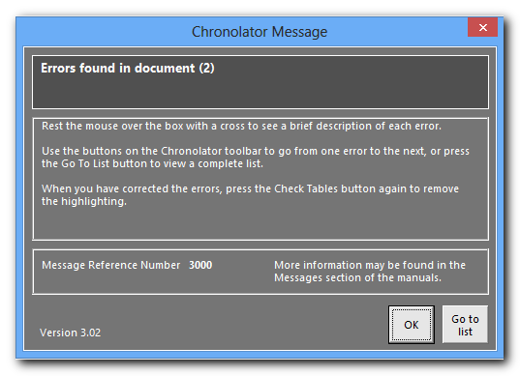
There are several ways for you to find the errors Chronolator reports:
- A flag like this is put at the left of the error.
- Hovering your mouse over the flag displays a brief description like this:
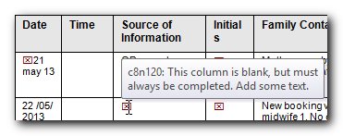
- Error text is highlighted. Invalid data is coloured turquoise, valid dates or times which are out of sequence are coloured yellow, and rows with the wrong number of columns are coloured purple;
- You can use the navigation buttons on the Chronolator toolbar to go from one error to the next. This is useful if you are working in a long document;
- There is a complete list of errors at the end of the document. Use the button to the right of the navigation buttons to go there.

Correcting errors
The following example illustrates the sort of errors Chronolator discovers, and shows how you might go about correcting them.
In this example, the Administrator has specified that you can leave any column blank apart from the Date and Source of Information columns.
The text in the Comments column describes the sort of errors Chronolator will find. It is not itself part of Chronolator’s checking.
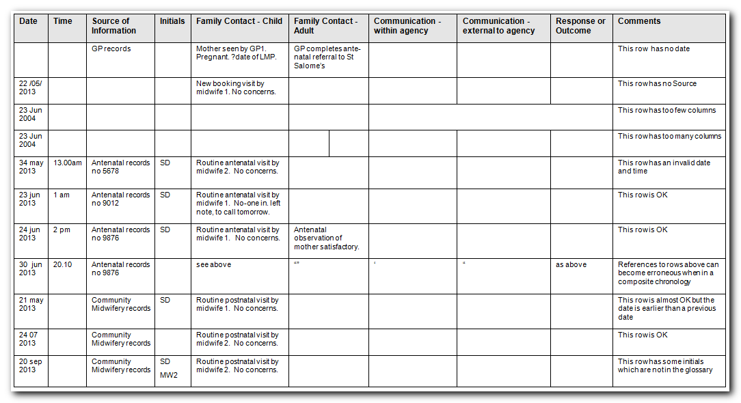
Figure 3 - faulty Chronology Table before checking
After Chronolator checks the table, it puts a flag to the left of any errors and highlights them like this:
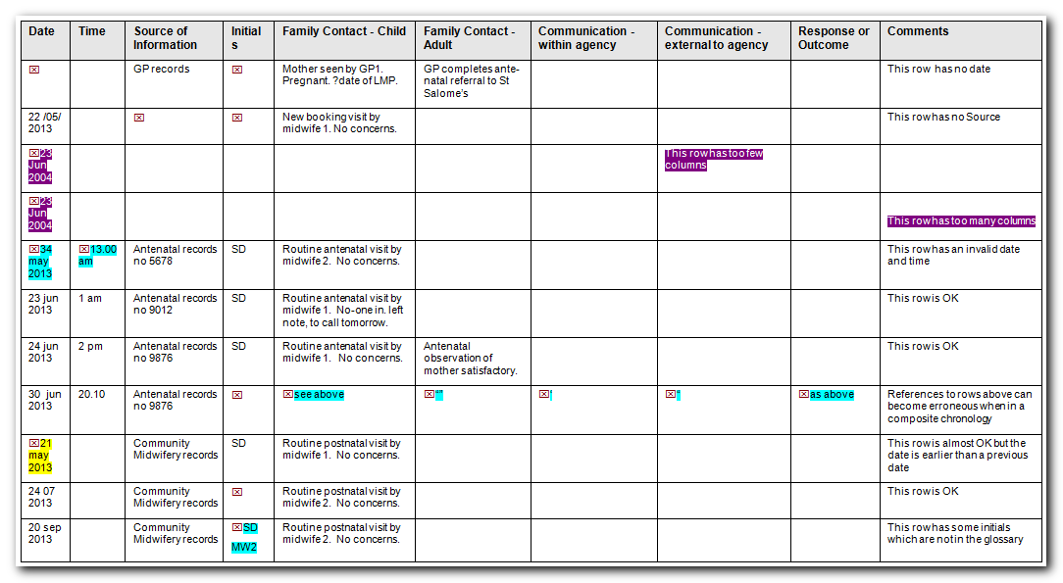
Figure 4 - faulty Chronology Table after checking
If you hover your mouse over the flag, a brief description of the error pops up.  Here, Chronolator warns that it has corrected a row with the wrong number of columns and advises the user to check that it has put information under the right headings. | 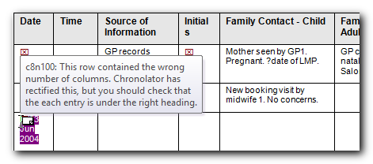
In this example, Chronolator has detected a blank entry in a mandatory column.
The buttons on the Chronolator toolbar navigate from one error to the next. | 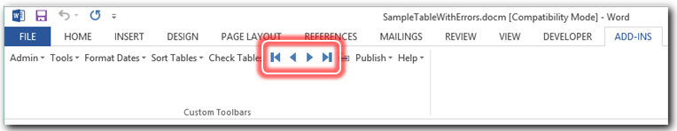
This button takes you to a list of the errors. | 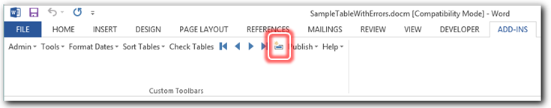
The list of errors is at the end of the document.  Double-click the flag to go to where the error occurs. | 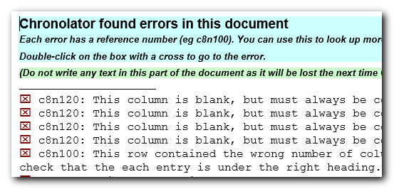
Error descriptions are preceded by a reference number (e.g. ‘c8n210’). If you have difficulty correcting an error, use the reference number to look it up in Check Table Error Codes on page 137, where there might be some useful hints.

CAUTION: Anything you write in or after the error list will be deleted next time Chronolator checks the document.

How you correct errors in a real document will obviously be a matter of judgement. For the purposes of this example, this is what we will do:
- add text to all the mandatory columns;
- review the rows which had the wrong number of columns, which are highlighted like this. In this case we decide that Chronolator has placed the data correctly, and leave it where it is;
- correct the invalid Date ’34 may 2013’ to ‘14 may 2013’.
- copy and paste the required data over the ‘See above’ text, and delete the ditto marks and ‘as above’ text.
The table now looks like this:
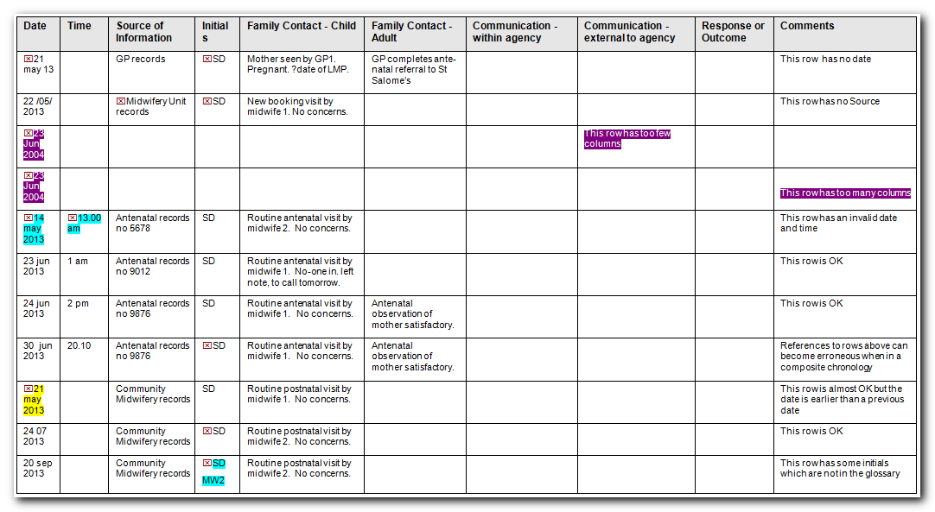

Notice that the corrected errors are still flagged and highlighted (apart from the ones we corrected with copy and paste). Chronolator does not check for errors as you type because doing so would make your computer run very slowly. You need to check the document again . . .
Pressing the Check Tables button again results in this:

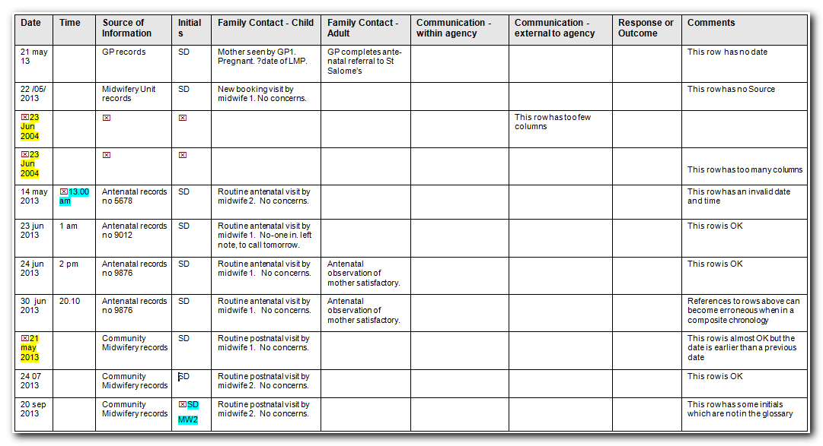
Most of the problems Chronolator has found are out-of-sequence dates, which it has highlighted in yellow. You could correct these by moving the rows about or by changing the dates for the appropriate events, depending on what is appropriate for the data you have entered.

The Sort Tables button
In the example above, you might decide that each event was in fact correctly dated but that the rows were in the wrong order. Indeed, this is the most likely cause if you have been entering each event in a new row at the bottom of the table as it came to hand. Chronolator will fix this for you with the Sort Tables button:
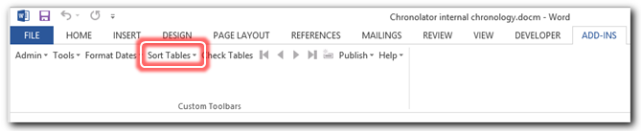
When you press it, you can choose to sort the table in ascending or descending order; press the one you want. If you press Ascending, the table is sorted like this:
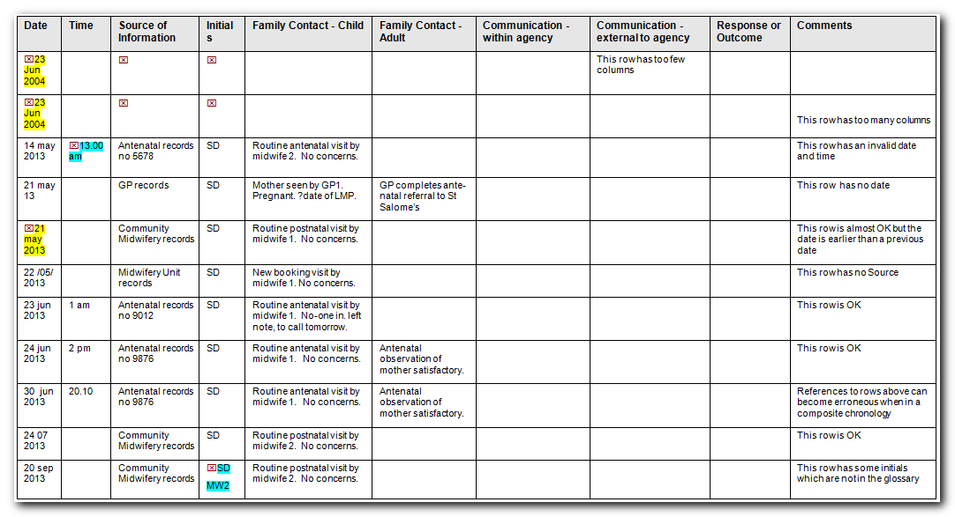

Remember, Chronolator does not check errors as you type; press the Check Tables button again to remove the highlighting:

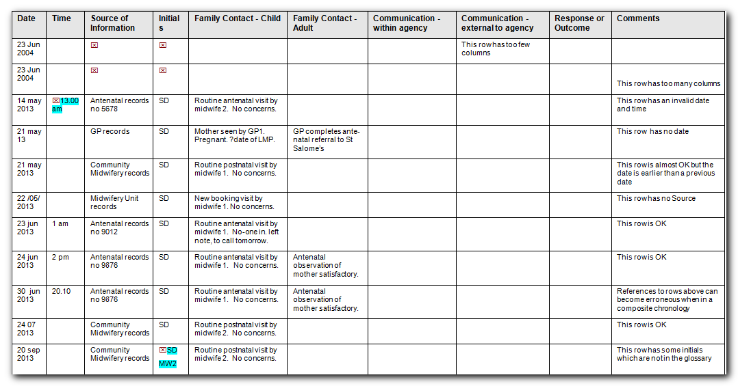
All the events are now in order. Some errors remain, but we will leave them for now.
You might have entered dates just as they appeared in the source records; in the example above, that is why many of the dates are in different formats. Chronolator can put them all into a consistent format for you; see Format Dates on page 41 for details.

How does Chronolator sort events with blank times and End Dates?
The Case Review Administrator might include optional End Date, Start Time or End Time columns which might not have to be completed for every event.
If so, you might wonder how Chronolator will deal with a mixture of events, some with completed times or end dates and some with blanks.
The answer depends on whether events are sorted in Ascending or Descending order. If Ascending, events with blank times or End Dates are put before those with specific information: if Descending, after. The following examples illustrate this.
Ascending order 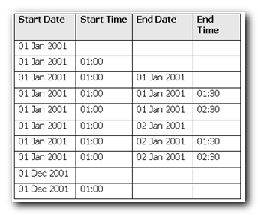 | Descending order 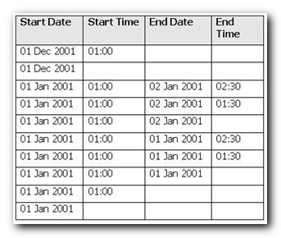

Creating a Composite Chronology document
This section describes how to merge individual Chronolator Documents into Composite Chronologies.

Administrators
A Composite Chronology is produced by an Administrator. In Chronolator terminology, there are two kinds of Administrator:
- Case Review Administrators have a licence for the Online Workbench and use it to set the criteria for an Internal Chronology;
- Local Administrators are people who, when they receive a Chronolator Document, decide to delegate completing it to several other people in their organisation.
A Local Administrator distributes copies of the document to other people and merges them into a Composite Chronology when they have been completed.
When the Composite Chronology has been completed, a Local Administrator returns it to the person who asked them for the information.
The flowcharts in Figure 1 on page 11 and in Figure 2 on page 12 illustrate the flow of documents between administrators and data collectors.
The only difference in administrators’ procedures is that a Case Review Administrator should use the Online Workbench to create a new Composite Chronology, while a Local Administrator must use the Chronolator Document toolbar.

Overview
Creating a new Composite Chronology involves the following steps:
- Make a blank Composite Chronology document;
- Import tables from the Chronolator Documents that have been returned to you;
- Merge the tables;
- Format the dates;
- Sort the tables;
- (Optional) Apply any final formatting that is required;
- (Optional) Publish the document with the Chronolator code removed.
You can wait until you have received all the documents before starting this process, or you can import, merge, format and sort each one as it comes in. It is up to you.
The following sections describe these processes step by step.

Step by Step Guide

Make a blank Composite Chronology document
How you make a blank Composite Chronology depends on what type of administrator you are:

If you are a Case Review Administrator | If you are a Local Administrator
Press the New Composite Chronology button on the Online Workbench toolbar. | Press the Admin > New Composite Chronology button on the Internal Chronology toolbar.
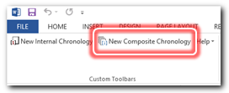 | 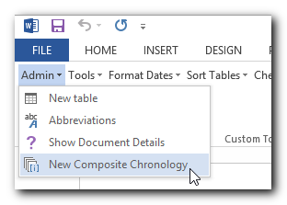

Chronolator displays Word’s Save As dialog for you to choose what to call the new Composite and where to save it.  Enter a suitable name and location and press Save.  If you are a Local Administrator, the Internal Chronology closes and the Composite Chronology is opened.  If you are a Case Review Administrator, the Online Workbench stays open when the Composite Chronology is created. You might need to switch to the Composite Chronology using the Windows taskbar. | 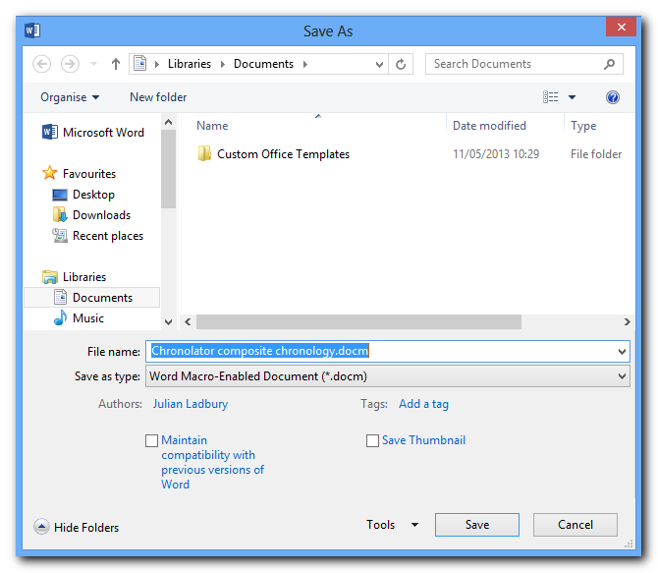

From this point on, there are no differences between what Case Review Administrators and Local Administrators do to produce a Composite Chronology.

Identify the Composite Chronology Toolbar
The Composite Chronology has a new toolbar. Chronolator never displays buttons for irrelevant tasks, so a new Composite Chronology contains just two buttons. | 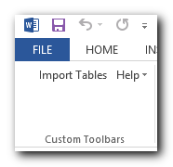
After you have imported the first document, the toolbar expands to include buttons for the other tasks that become possible. | 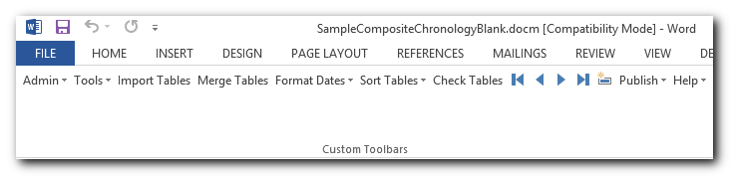

Import Chronology Documents into the Composite Chronology

Identify and check a file to import
Although Chronolator will have warned people if it found errors in their documents, it cannot force them to correct them. Before you import a document, you should open it and check it using the Check Tables button on its own Chronolator toolbar.
If the document has errors which you cannot correct yourself, ask the person who sent it to you for clarification, or return it to them for correction; it is better to sort things out now rather than later.
If you are satisfied with the document, close it and return to your Composite Chronology.

Press the Import Tables button
Press the Import Tables button to display Word’s Open dialog. Open the document you want to import.
When you import a document into a new Composite Chronology, Chronolator copies in the entire document, including its preamble (if any) and the internally stored Case Details.
When you import subsequent documents, Chronolator checks that they relate to the same case and copies all tables matching the Case Details to the end of the Composite Chronology.

Specify where the document came from

After checking that the document contains tables with the right headings, Chronolator asks you to identify where it came from. For example, if you were to import a document from the Police, you might enter this: | 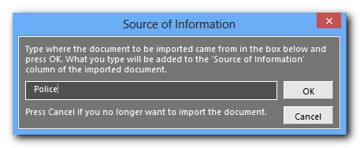

When you press OK, ‘Police >’ will be added to whatever is already in the Source of Information column.

For example, if the Police’s document contains these entries . . . | 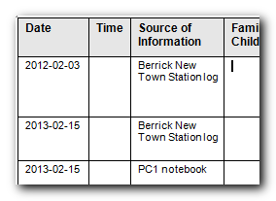
. . . after you have imported it, they will look like this: | 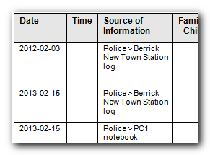

You can import all the documents you have to hand before proceeding to the next step, or you might prefer to import, merge, and format them one by one. It is up to you.

Merge tables in a Composite Chronology
Use the Merge Tables button to combine all the tables in the Composite Chronology into a single table. | 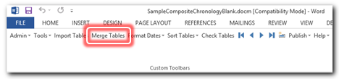
Chronolator automatically resizes any tables whose column widths are different from those of the first table.

Format Dates
The various organisations and departments who completed the Internal Chronology documents you distributed will probably have entered dates in a variety of different ways (01.02.04, February 1 2004, 1/2/4 and so on). This does not hamper Chronolator’s validity checks, but it does look untidy.
You can use the Format Dates button to put them all into a consistent format. When you press it, you will see today’s date displayed in four different formats. Press the format you want. | 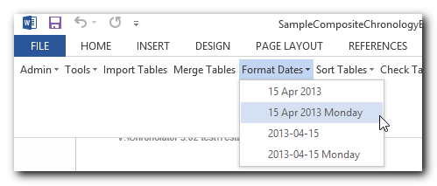
The available formats present January 2 2001 as 02 Jan 2001 or 2001-01-02. The latter is the ISO 8601 format. Both formats can be enhanced with the day of the week, which can be useful for a reviewer trying to establish patterns of behaviour.
When you format dates, any Time columns are also formatted. The format conforms to ISO 8601 (a 24-hour time delimited by a colon, e.g. 18:15).

Sort a Chronology
Use the Sort Tables button to sort the merged table into the correct order. When you press it, a menu drops down so you can choose whether to sort the table in ascending or descending order. | 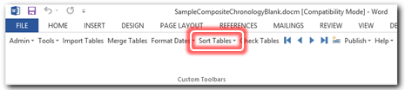
Press the order you want. Chronolator will sort the table using the Date and Time columns that the Case Review Administrator specified.
Chronolator puts untimed events for a particular day before timed events when sorting in Ascending order, or after them when sorting in Descending order. See How does Chronolator sort events with blank times and End Dates? on page 36 for an example.

Sorting mixed formats
Putting dates and times into a consistent format before sorting is recommended as it makes the sort easier for Word, and thus more reliable.
Early versions of Word had a bug which prevented Sort from working in some circumstances. Circumventing that bug was the reason for introducing the ISO 8601 format, which Word unfailingly sorted correctly. If you do encounter problems sorting, try this:
  - Press Format Dates and choose the ISO 8601 format;
  - Press Sort Tables;
  - Press Format Dates again and choose your desired format.

Final checks
You can use the Check Tables button to make a final check that the Composite Chronology is valid as far as Chronolator is concerned. | 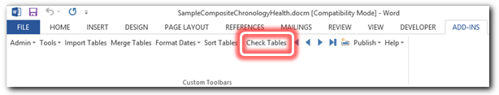

You should also read through the document to make sure it makes sense. Chronolator certainly simplifies the process of producing these documents, but it is only a computer program and cannot correct human failings!
In particular, you might want to check that any time-critical events are in sequence if the document does not contain Chronolator’s Start Time or Finish Time columns. If they are not, consider using a Sequence column.

Publishing a chronology document
When you have completed a chronology document you can publish it without the Chronolator program code so that your recipients will not have to do anything about macros and licence terms whenever they open it.
Pressing Publish > Exact Copy copies everything to a new document, and then displays Word’s Save As dialog so you can choose where to save it. | 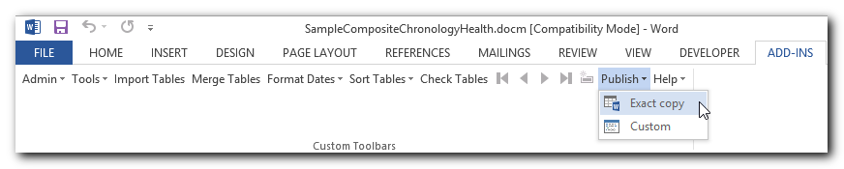
The original Chronolator document is unchanged by this process.
You can also publish the chronology in a variety of narrative formats. See Narrative formats on page 67.

Advanced Features and Productivity Tools
Most of the advanced features of Chronolator are on the Tools menu:
- The Age and Interval Calculator - see The Age and Interval Calculator below.
- Anonymisation and Personalisation, including review of selected abbreviations - see Anonymisation and Personalisation on page 55;
- Duplicate Row Processing - see Working with Duplicated Rows on page 46;
- Adding reference numbers to events, and using them to force the order in which they are sorted - see Using a Sequence column on page 59;
- Highlighting events according to their Source of Information - see Highlighting Sources of Information on page 64;
- Using Add-ins, which add extra functions to Chronolator - see Add-ins on page 71.
Items on the Publish menu let you create versions of a chronology without any Chronolator code, and in a variety of narrative formats - see Publishing a chronology on page 67.
On the Admin menu, Abbreviations lets you update individual entries in the Abbreviations Glossary - see Working with the Abbreviations Glossary on page 50.

The Age and Interval Calculator
You will often want to work out the interval between two dates when working on a chronology. Chronolator provides a tool to do this for you when you press Tools > Age Calculator on the Chronolator toolbar. | 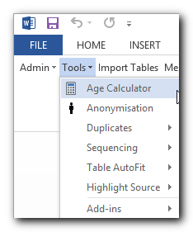
If you have not used the Age and Interval Calculator before in this document, Date 1 has today’s date in it, and Date 2 is blank.  If you have used it before and saved the document, the last two dates you used will be shown. | 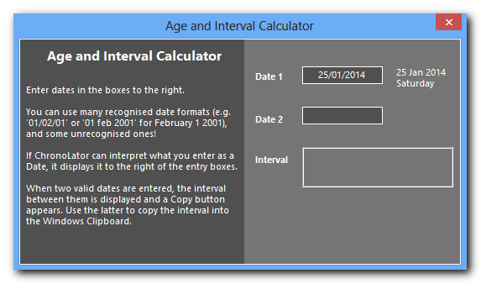
You can type dates into the boxes in many formats. As you type, Chronolator displays what it thinks you mean next to the box.  When Chronolator can interpret dates in both boxes, it calculates the interval between them.  The interval is shown as a number of days and as a number of years, months and days.  It does not matter which date is the earlier one. | 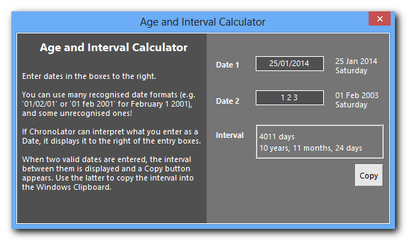
You can copy the interval information to the Clipboard by pressing the Copy button, and then paste it into your document. The example above is copied to the Clipboard as 10 years, 11 months, 24 days (4011 days). Once pasted into the document, you can edit it as you choose.
Using the Age and Interval Calculator is quite straightforward, but it is worth noting some details about how it works under certain circumstances. (If you are not interested in the minutiae of Date calculations, stop reading now and just use the calculator!).

Awkward calendars
‘Thirty days has September, April, June and November’… We are taught this rhyme when we are young, and learn to cope with the different number of days in each month over many years. However, innocent as it sounds it provides many a stumbling block when working out the interval between two days. The numbers of days between two dates is always unequivocal, but if we want to give this as ‘x Years, y Months, z Days’ we come across problems of interpretation. The following sections give examples of these problems and describe how Chronolator deals with them. There is no single ‘right method’; we hope that Chronolator’s results match most people’s interpretations.

Easy calculations
When the Day number of the later date is equal to or larger than that of the early date, things are quite straightforward:

Early Date | Late Date | Interval
23 January 2001 | 25 June 2002 | 1 year, 5 months, 2 days
01 December 2001 | 02 January 2002 | 0 years, 1 month, 1 day

Slightly harder calculations
When the Day number of the later date is less than that of the early date, things can get a bit harder. However, as long as the Day number of the early date is less than or equal to the number of days in the month before the later date, there is not too much of a problem:

Early Date | Late Date | Interval
31 January 2001 | 01 June 2002 | 1 year, 4 months, 1 day

Most people would probably work this out as follows:
- One year from 31 January 2001 = 31 January 2002;
- Adding 4 months takes us to 31 May 2002;
- Adding 1 final day gets to our target, 01 June 2002;
- That is, 1 year, 4 months, 1 day in all.
So far, so good!

Difficult calculations
Now look at what happens when the Day number of the early date is more than the number of days in the month before the later date:

Early Date | Late Date | Interval
31 January 2001 | 01 May 2002 | ??

Comparing this to the previous example, 01 May 2002 is exactly one month earlier than 01 June 2002, so we might expect the answer to be exactly one month less; that is, 1 year, 3 months, 1 day.
However, if we use the same method as above:
- One year from 31 January 2001 = 31 January 2002
- Adding 3 months takes us to 31 April 2002!
- But April only has 30 days, so we must already have arrived at 01 May 2002.
That being the case, our interval is 1 year, 3 months, 0 days in all - one day less than expected!

The Chronolator solution
The Age and Interval Calculator works so that the above ‘surprise’ does not occur. From a date at the end of a month to the first of another month is always x Years, y months, and 1 day. For example:

Early Date | Late Date | Interval
31 January 2001 | 01 May 2002 | 1 year, 3 months, 1 day
30 April 2001 | 01 March 2004 | 2 years, 10 months, 1 day
31 May 2004 | 01 December 2005 | 1 year, 6 months, 1 day

This solution looks very plausible, but it does give rise to an anomaly. For example, the interval from 30 January to 01 May is the same as that from 31 January!

Early Date | Late Date | Interval
30 January 2001 | 01 May 2002 | 1 year, 3 months, 1 day
31 January 2001 | 01 May 2002 | 1 year, 3 months, 1 day

On balance, we feel that this solution most likely does accord with what most people want. However, if you disagree, please let us know by making a suggestion at www.chronolator.co.uk/suggest_form.htm.

Working with Duplicated Rows

Use Tools > Duplicates to highlight or delete duplicated rows. | 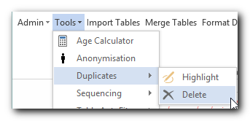

How duplicated rows can occur
Duplicated rows can occur for various reasons. For example:
- you might have broken off completing an Internal Chronology for a while, and inadvertently entered the same records twice;
- someone might send you a new version of an Internal Chronology containing a few extra events when you have already merged the original into a Composite Chronology. Rather than having to pick through it all and take out the new events, you can import the new document in its entirety and let Chronolator identify and delete them.
Sometimes however, duplicates - or near-duplicates - might occur for other reasons. It could be that two different agencies report the same event in exactly the same way. Although this might be unlikely, Chronolator is designed to help you identify and analyse potentially duplicated events however they occur.

Highlight or Delete?
Chronolator can either highlight duplicated rows or delete them. You might want to highlight and review them before deleting them.
If you wish, Chronolator will save deleted duplicates in a separate document.

Ignoring the Source of Information when identifying duplicates
You can instruct Chronolator to ignore the Source of Information column when looking for duplicates. You might want to do this if you have inadvertently imported a Chronolator Document twice using two different Source Prefixes.

Examples
The various options are illustrated below using the following table. Although somewhat implausible, it does provide a useful illustration of the options.
All four rows are identical, with the exception of the Source of Information entry in the second row.
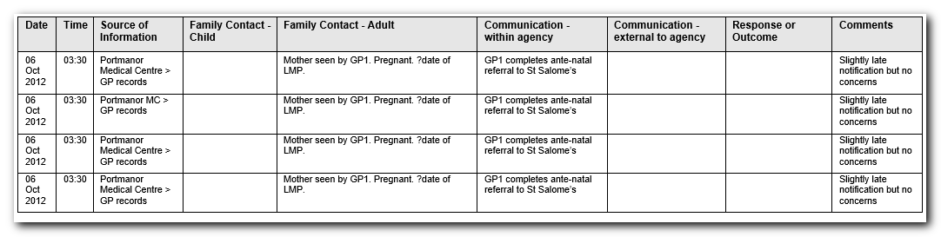

Highlighting duplicates
When you press Tools > Duplicates > Highlight, the Duplicate Rows form is displayed:  It contains a check box labelled Ignore source column. | 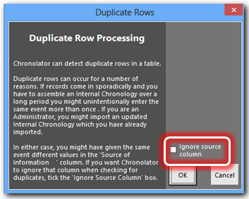

If you leave the check box blank and press OK, only the last two rows will be highlighted: | 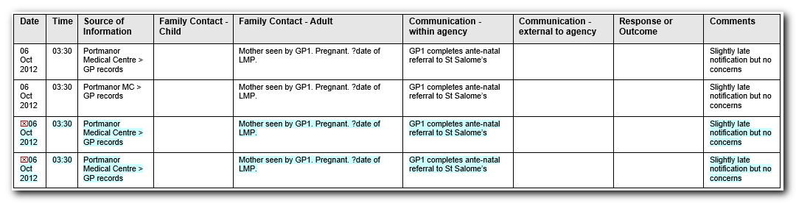
In contrast, if you tick the box before pressing OK, the last three rows will be highlighted: | 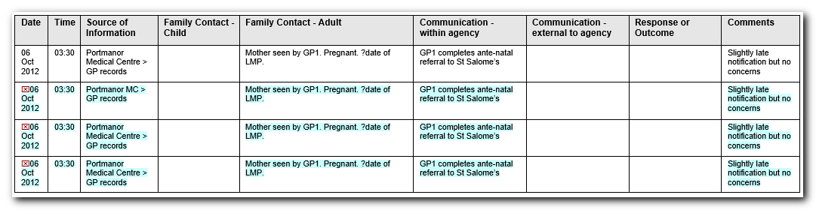
The navigation buttons on the Chronolator toolbar can be used to go from one duplicate row to the next in a long document. | 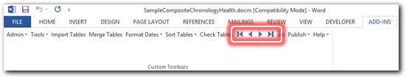

Deleting duplicates
When you press Tools > Duplicates > Delete, the Duplicate Rows form is displayed with an extra option:  If you want to save any rows which are deleted in a new document, tick the Copy Deleted Rows check box. | 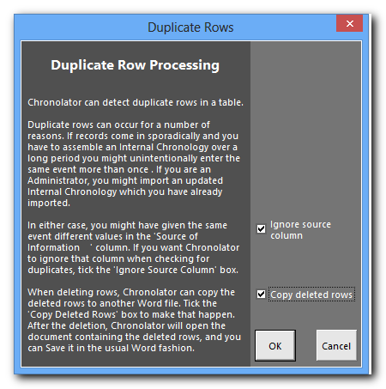
After you press OK, Chronolator tells you it has deleted some duplicates (3 in this example). | 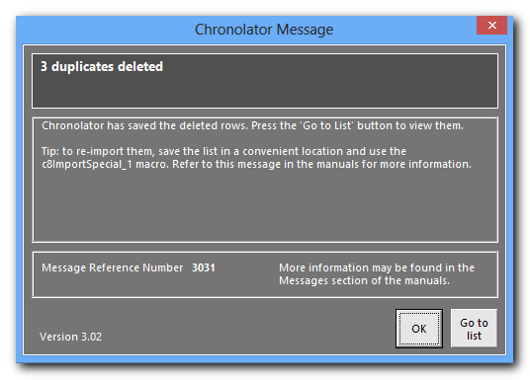
Press Go to list to switch to the new document containing the deleted rows.  The description of Message 3031 on page 116 has some suggestions about how you can use the new document to recover the deleted rows should you wish to do so. | 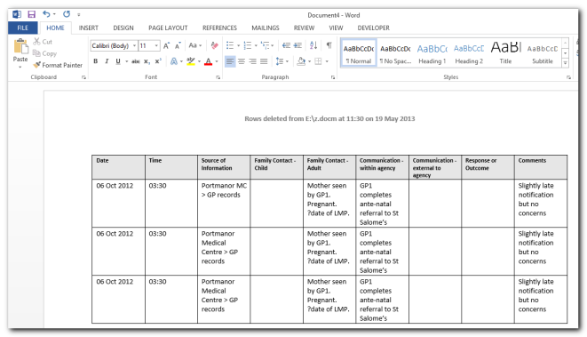

Working with the Abbreviations Glossary
The Case Review Administrator can define entries in the Abbreviations Glossary of a new Internal Chronology. Those entries cannot be changed or deleted by anyone else.
Anyone can add and change their own entries. Chronolator keeps track of what abbreviations have been defined in which document.
Abbreviations can be up to 10 characters long, and their Definitions up to 30.

Viewing and printing abbreviations

Press Admin > Abbreviations:  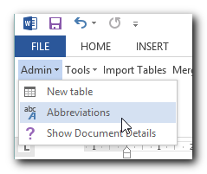 | The Abbreviations Glossary form is displayed showing the abbreviations in the document and their definitions:  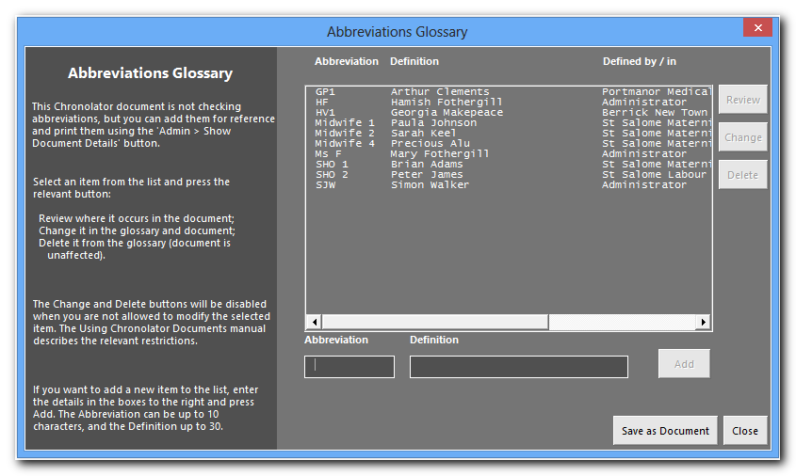  The Defined by / in column shows where an abbreviation has been defined. In an Internal Chronology, it will state either ‘Administrator’ or ‘This Document’. In a Composite Chronology, it will include the path to any imported documents, as shown above.  If you want to produce and print a list of the abbreviations, press the Save as Document button.  When you have finished, close the form by pressing the Close button.

Adding an abbreviation

Press Admin > Abbreviations: | The Abbreviations Glossary form is displayed showing the abbreviations in the document and their definitions:
Type the new Abbreviation and its Definition in the boxes, and press Add:  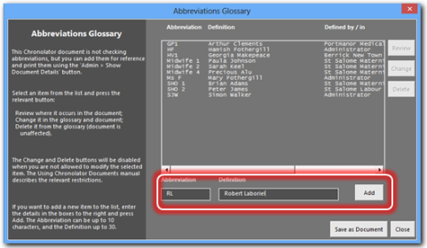 | The new entry is added to the list:  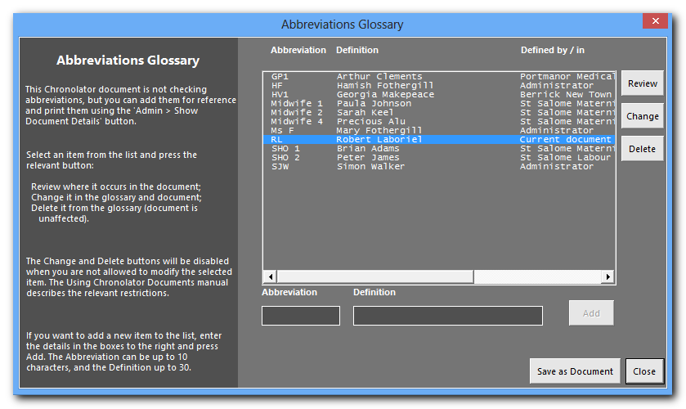

Changing an abbreviation
Since agencies can add their own entries to the Abbreviations Glossary, it is possible that two of them might add similar entries (for example, AD/Alan Daniels and AD/Adam Donoghue). Chronolator always keeps track of where an abbreviation has been defined, but if you want to use the Anonymisation feature all abbreviations and definitions must be unique.
You can use the Admin > Abbreviations tool to change a user-defined Glossary entry. Chronolator updates the glossary and makes any required changes in the document.
The following example uses the Abbreviation GP1 and corresponding Definition Arthur Clements shown in the example above. The document text contains this event (Arthur Clements is in column 4, and GP1 in column 5):
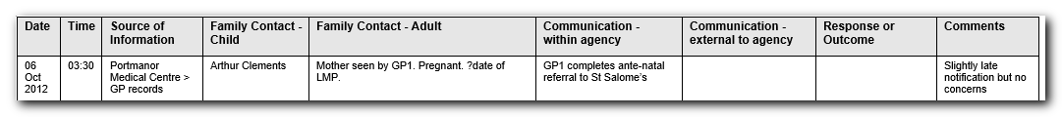
Press Admin > Abbreviations: | The Abbreviations Glossary form is displayed.
Click GP1 Arthur Clements. and press Change. | 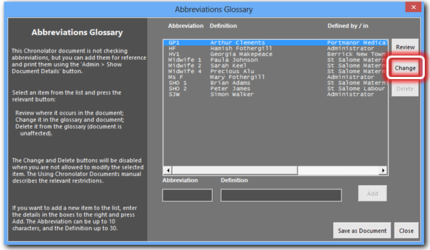
The current abbreviation and definition appear in the boxes near the bottom of the form, with a message inviting you to change them: | 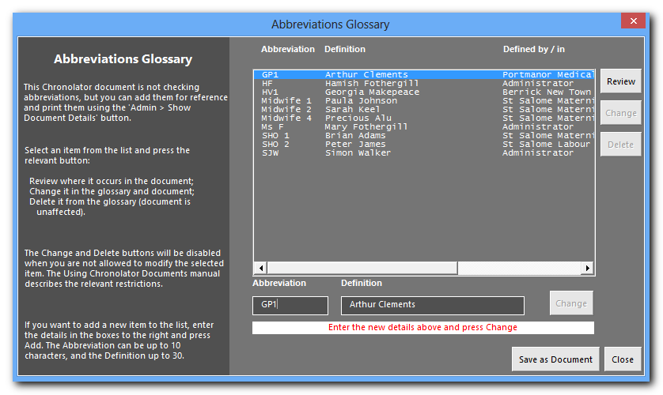
Type in the new information and press the Change button to the right of it. In this example, we change both the Abbreviation and the Definition to GP99 and Xaviera Yarrup respectively, but you can choose just to do either one. | 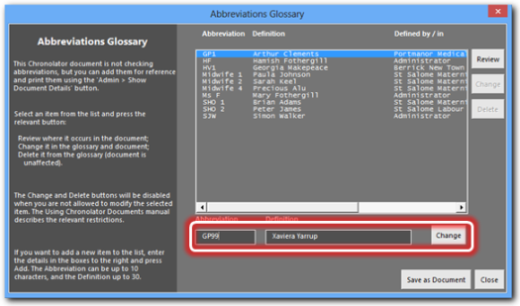
Use the scroll bar at the bottom of the abbreviations list to scroll it to the right. | The original entry is still there, so you can always find it in the document in which it was first defined:  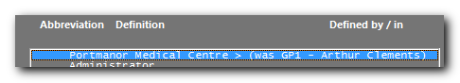  If you are using this feature to anonymise a document, remember not to publish it without first using the Publish > Exact Copy tool to produce a copy without any Chronolator code, and hence without the ability to reveal the abbreviations.
Press the Close button in the bottom right hand corner of the form. | Chronolator updates the document with the changed entry: GP1 and Arthur Clements are changed to GP99 and Xaviera Yarrup respectively:

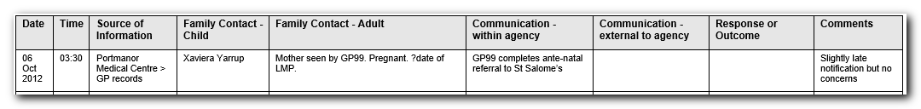

Browsing a document using the Abbreviations Glossary
The Review button on the Abbreviations form lets you use a glossary entry to navigate through the chronology. You can also produce extracts containing just the events pertaining to an entry.
For example, suppose you want to scroll through a document looking for events involving, say, GP1. Press Admin > Abbreviations, select GP1, then press Review. | 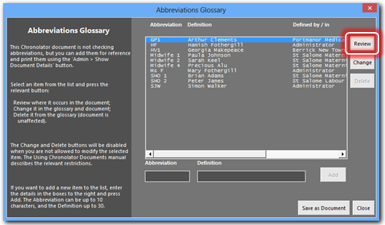
For further details, see Reviewing and changing how entries in the Abbreviations Glossary appear in the text on page 56. It uses the Review button on the Anonymisation form, which lets you process more than one glossary entry at a time - you can only process a single one with the Review button on the Abbreviations Glossary form.

Anonymisation and Personalisation
Chronolator can anonymise a document according to the entries in the Abbreviations Glossary. It can be hard for a reviewer to build up a mental picture of the people involved in a review when they are only referred to by their initials, so Chronolator lets you switch between anonymised and personalised views.
The Anonymisation feature is found at Tools > Anonymisation | 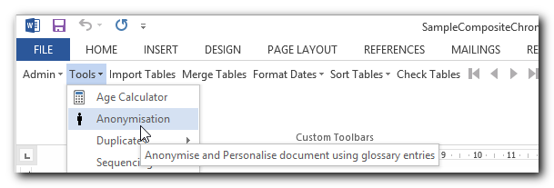

Warning
The Anonymisation feature can format abbreviations like this to make them stand out in the document. This formatting will be lost when some other features are run, so it is recommended that you do not use Anonymisation until you have finished with those other features.  Chronolator warns you about this by displaying Message 7010 the first time you press Tools > Anonymisation in a Word session. | 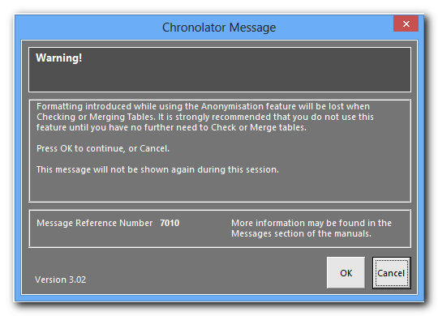

Switching between Anonymised and Personalised views of a document

When you press Tools > Anonymisation (and OK on Message 7010 if it is issued), the Anonymisation form is displayed showing the abbreviations in the document and their definitions.  Place a tick against the abbreviations you want to process. The All, None, and Flip buttons at the top of the form can make this quicker. | 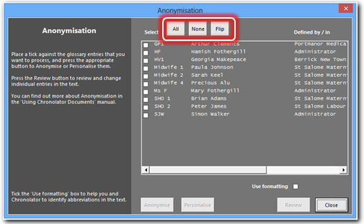
After you have selected one or more abbreviations (in the example here, all have been selected) the Anonymise and Personalise buttons work together with the Use formatting checkbox. | 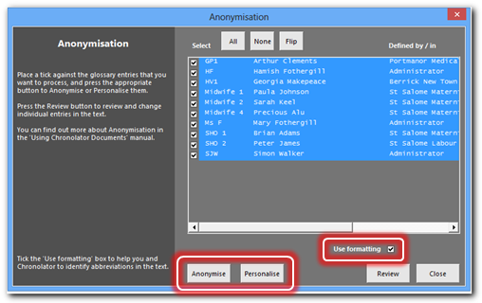
If the Use formatting checkbox is ticked when a document is being Anonymised, the resulting abbreviations will be formatted like this (i.e. Bold, Underlined and Italic). This has two advantages:
- abbreviations stand out in the document;
- Chronolator can distinguish between entries in the Glossary and any common words which are spelt the same (for example, if there were an abbreviation The for Timothy Henry Edwards).
If the Use formatting checkbox is ticked when a document is being Personalised, only those occurrences of an abbreviation which are formatted like this will be changed.

Reviewing and changing how entries in the Abbreviations Glossary appear in the text
The Review button on the Anonymisation form lets you use glossary entries to navigate through the chronology.
During the review, you can change how individual entries appear in the text (as Abbreviations with or without highlighting, or as Definitions).
You can also produce extracts containing just the events pertaining to selected entries.
Suppose we are interested in GP1/Arthur Clements and Midwife1/Paula Johnson.

Press Tools > Anonymisation to display the Anonymisation form, then tick GP1 and Midwife1, and then press the Review button: | 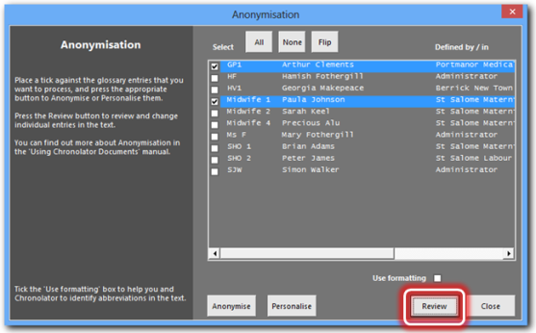
The Change Abbreviations form is displayed, and occurrences of the entries are highlighted in the document.  The active occurrence is highlighted like this, and the others like this. | 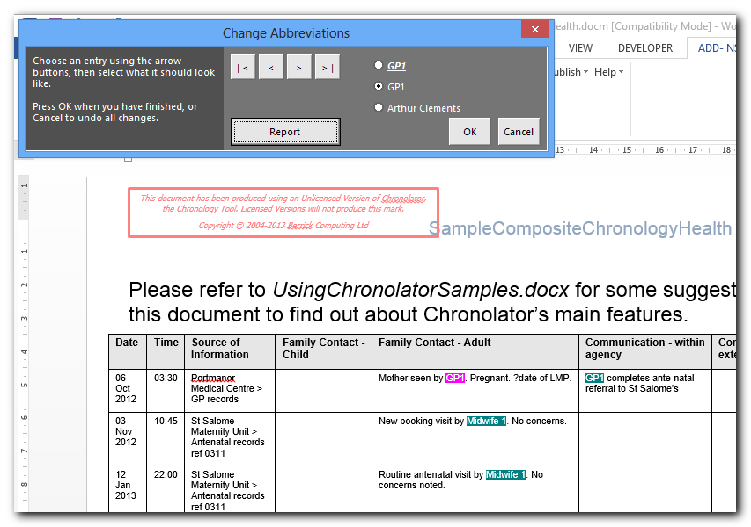
Use the navigation buttons in the form to scroll among the occurrences of GP1/Arthur Clements and Midwife1/Paula Johnson: | 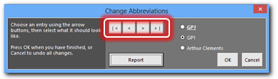
The radio buttons let you change the text of the active occurrence to whatever you select: | 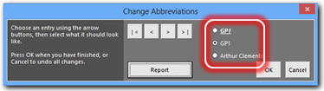
When you have finished, press OK or Cancel, depending on whether you want to save any changes. | 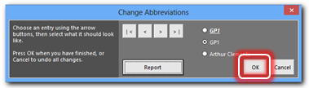

Producing an extract of events containing selected Glossary entries
You can produce a new document containing just the events pertaining to selected glossary entries.
Press Tools > Anonymisation:
Select the entries in which you are interested, then press the Review button:

When the Change Abbreviations form is displayed, press the Report button: | 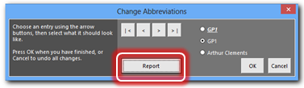
A new document is created, containing only those events which involve the glossary entries you selected: | 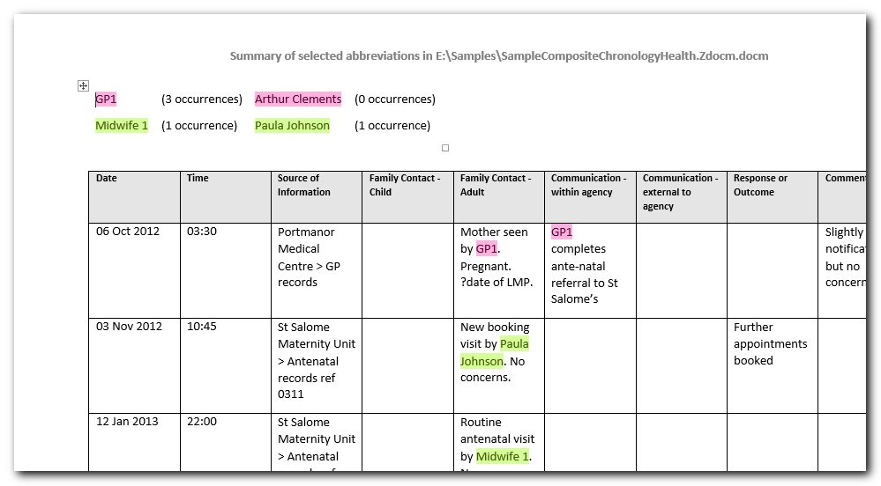

The counts at the top of the report pertain to the abbreviations originally selected in the Anonymisation form, not those listed in the report. Changes you make before pressing Report will not be reflected in these counts. Similarly, if some abbreviations are formatted, the report counts might not match the highlights in the report.

Using a Sequence column
The first column in a chronology table can be a Sequence column, which provides two main benefits:
- it can contain a reference number for each event;
- you can use it to specify the order of events on a particular day when you do not know their times.

Defining a Sequence Column
The Case Review Administrator can define a Sequence column when setting up the chronology document.
End-users can define one using the Tools > Sequencing > Add column button. (This is the only change Chronolator allows to Administrator-defined column headings).

Changing the Sequence Column Heading
The default heading for a Sequence column is Seq, but you can change it once it has been added (unless it was defined by the Case Review Administrator):
Press Tools > Sequencing > Change Column Heading: | 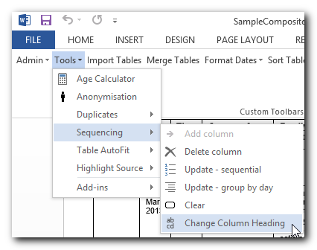
In the form which is displayed, type the new heading - for example ‘Reference’ - and press OK: | 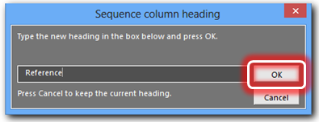

Giving events a Reference Number
Chronolator can add a Reference Number to each event. Numbering can be restarted at 1 on each new day if desired.
Press Tools > Sequencing > Update – sequential to give each event a unique number: | 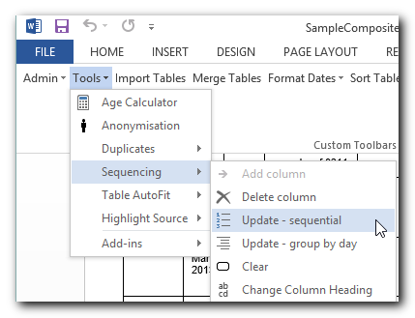
Press Tools > Sequencing > Update - group by day if you want the numbering to start at 1 on each new day: | 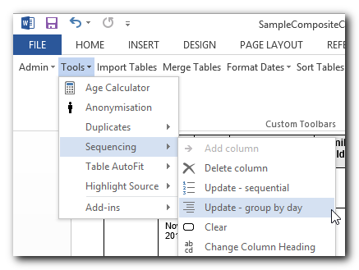

Forcing events into order
Sometimes you might not know at what time events happened on a particular day, but you do know their order. You can use the Sequence column to specify it.
In this example from a multi-agency chronology, the time has only been given for one of the events of March 15, and events are in the wrong order: | 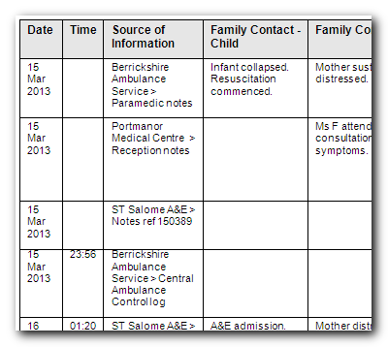
We can put them in the right order by typing the correct sequence numbers in the Sequence column of each event . . . | 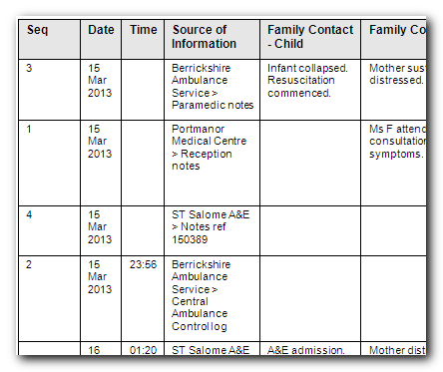
. . . and pressing Sort Tables > Ascending: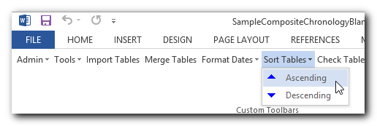 | 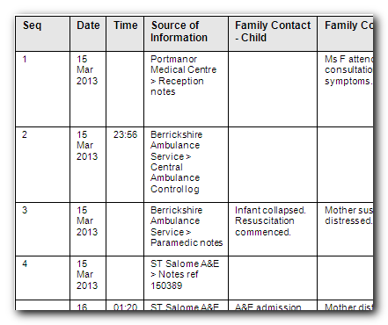

You do not always have to update sequence numbers in all the events, as the sort recognises decimal numbers. For example, suppose that you now wanted to put event 4 before event 2 (this might not make sense in terms of the story, but we will do it here just to illustrate the feature).

Replace the ‘4’ in the event with a number between 1 and 2 - ‘1.5’ say: | 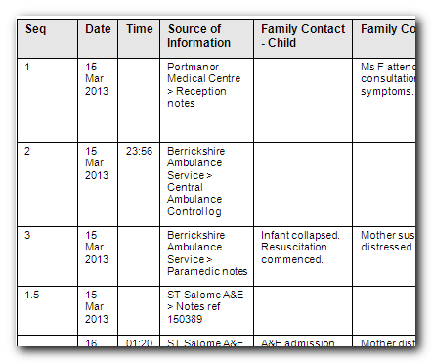
Press Sort Tables > Ascending to put the events into the requested sequence: | 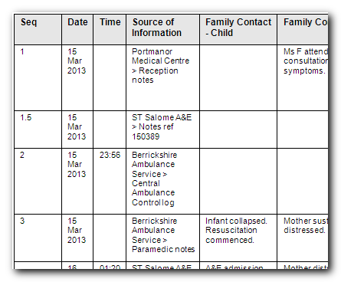
Press Tools > Sequencing > Update - group by day to replace any decimals with whole numbers: | 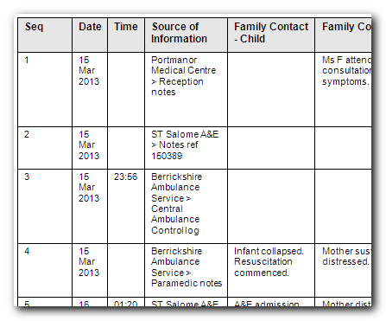

If you force events into an incorrect date/time sequence using a Sequence column, Chronolator will detect the problem when it checks for errors.

Sequence column conflicts when Importing a chronology
Because anybody can add a Sequence column it might happen that an Internal Chronology has one but not a Composite Chronology - and vice versa.
When such conflicts occur, Chronolator lets you decide whether to keep or discard the column. See the descriptions of Messages 1030 and 1031 on page 105 for more details.

Highlighting Sources of Information
Chronolator can highlight events from different agencies in a multi-agency chronology in a number of ways. Agencies are distinguished by the Source Prefix they are given when their chronologies are imported.
Press Tools > Highlight Source > Define and Do to open the Highlight Source options selector:  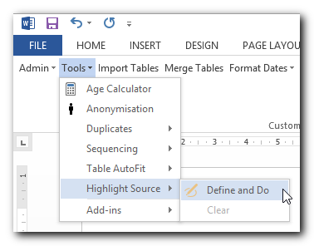 | 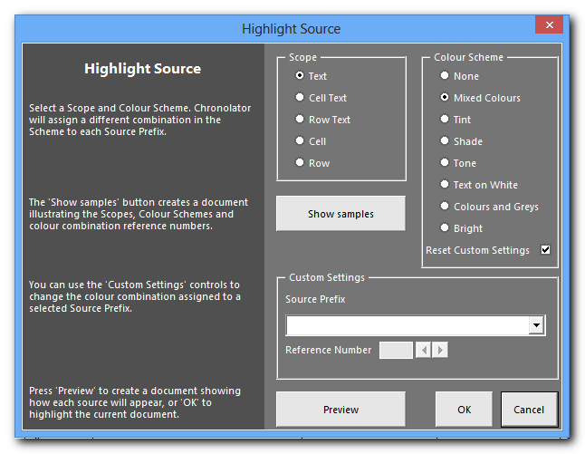
The main choices you make here use the buttons in the Scope and the Colour Scheme boxes. A document containing a detailed description of how these work can be obtained by pressing the Show Samples button.

Scope
The Scope controls how much of the event is highlighted. The lowest scope highlights just the text of the agency’s Source Prefix, while the most extensive scope highlights the background of the entire row.
For example, here is how the agency Berrick Police would be highlighted using each Scope:
Scope
Text | Berrick Police > New Town Station > Custody records | Chronolator - the Chronology Tool | Chronolator - the Chronology Tool
Cell Text | Berrick Police > New Town Station > Custody records | Chronolator - the Chronology Tool | Chronolator - the Chronology Tool
Row Text | Berrick Police > New Town Station > Custody records | Chronolator - the Chronology Tool | Chronolator - the Chronology Tool
Cell | Berrick Police > New Town Station > Custody records | Chronolator - the Chronology Tool | Chronolator - the Chronology Tool
Row | Berrick Police > New Town Station > Custody records | Chronolator - the Chronology Tool | Chronolator - the Chronology Tool

Colour Scheme
Chronolator’s built-in Colour Schemes provide a quick way to set the highlighting for all prefixes. For example, this is the Mixed Colours scheme:
001  (7.81) | 002  (6.68) | 003  (9.01) | 004  (8.79) | 005  (6.82) | 006  (13.76) | 007  (7.79) | 008  (5.72)
009  (5.35) | 010  (4.74) | 011  (4.81) | 012  (4.60) | 013  (4.76) | 014  (4.61) | 015  (6.37) | 016  (5.73)
017  (7.81) | 018  (6.68) | 019  (9.01) | 020  (8.79) | 021  (6.82) | 022  (13.76) | 023  (7.79) | 024  (5.72)
025  (5.35) | 026  (4.74) | 027  (4.81) | 028  (4.60) | 029  (4.76) | 030  (4.61) | 031  (6.37) | 032  (5.73)
This is the Bright scheme:
177  (5.25) | 178  (12.70) | 179  (19.56) | 180  (16.21) | 181  (16.75) | 182  (9.90) | 183  (8.59) | 184  (4.66)
185  (5.63) | 186  (17.52) | 187  (8.77) | 188  (5.19) | 189  (15.82) | 190  (5.48) | 191  (6.70) | 192  (7.31)

The first number in each coloured box is its Chronolator reference number, which can be used if you want to override a scheme colour for a particular agency.
The numbers in brackets give an idea of how legible the highlight might be when viewed on a computer screen. They are calculated using the Web Content Accessibility Guidelines (Version 2.0) at www.w3.org/TR/WCAG/. Higher values represent better legibility. All of the Chronolator Colour Scheme highlights meet or exceed WCAG level AA.

Custom Settings
When there are only a few agencies in the chronology a default scheme should make it easy to distinguish each one. However, when there are lots of agencies you might get a better distinction between them by choosing highlights from different schemes.
For example, in the Mixed Colours scheme it is quite easy to see the differences between the first eight highlights, but probably not so easy to distinguish between highlights 004 and 014. In such a case, you can override the scheme colour for one or more agencies by using the Custom Settings box. Select the agency you want to modify, and then choose its colour by using the left/right arrows or typing in its Reference Number. Note that you will not be able to type in a number that is already in use.
If you have set a custom colour for an agency, Chronolator will retain it when you choose a new Colour Scheme unless Reset Custom Settings is ticked.

Previewing and Doing
Highlighting a large chronology can take a few minutes. The Preview button quickly produces a new document illustrating how each agency will appear.
When you are happy with your definitions, press OK to highlight the chronology.

Using highlights to get an overall picture of an agency’s involvement
When reviewing a large chronology, you can get an overview of which agencies did what when by highlighting it and then using Word’s Zoom feature to zoom out. For example, the following chronology has been highlighted with Scope: Row and Colour Scheme: Bright, and zoomed to 10%:
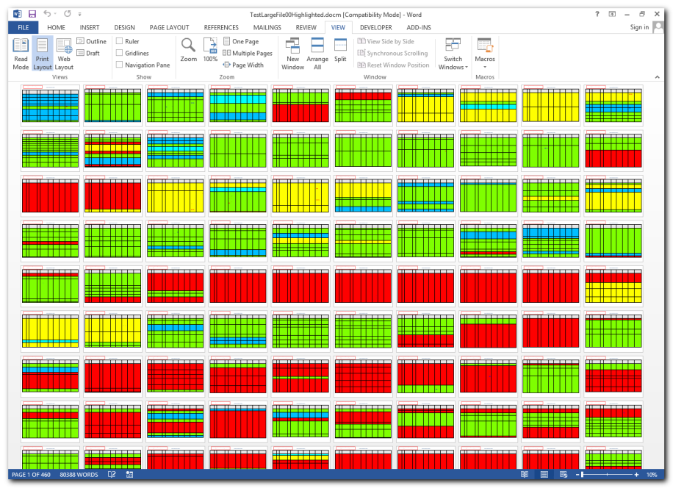

Publishing a chronology
When you have completed a chronology document you can publish it without the Chronolator program code so that your recipients will not have to do anything about macros and licence terms whenever they open it.
You can also publish the chronology in a variety of narrative formats.
Published chronologies are new documents: the original Chronolator document is not changed.

Exact Copy
Pressing Publish > Exact Copy copies everything to a new document, and then displays Word’s Save As dialog so you can choose where to save it.

Narrative formats
Although tables are a good way to put a chronology together, they can be unwieldy to read, particularly when a single event has a lot of text in one column that spans several pages.
Chronolator can convert a chronology table to a number of narrative formats, some of which include the elapsed time since the start of the chronology.
Press Publish > Custom  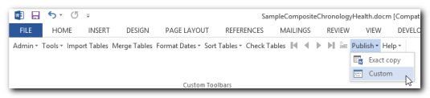  to display the Published Document Customisation form: | PublishCustom02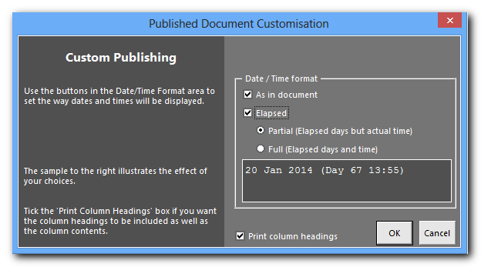
The choices you make influence what headings are displayed in the narrative.

Main heading - Sequence, Date and Time
If the chronology contains a Sequence column, it will be the first part of the main heading for each event in the chronology.
The options in the Date / Time format box control how the rest of main heading is displayed:
- As in document: date and time information will be copied exactly from the document;
- Elapsed: information about how long it has been since the start of the chronology is included. This always includes the number of days. Two sub-options control how the time is treated:
  - Partial: the actual time of the event is used;
  - Full: the elapsed time is used.

The dark grey box is updated as you change options to illustrate their effect: | 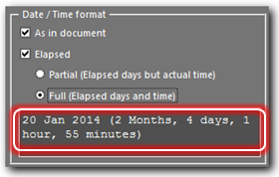

Other headings

After the main heading, the narrative includes information from the non-blank entries for each event. The Print column headings box controls whether their individual headings are included.

Examples
Take these events as an example:
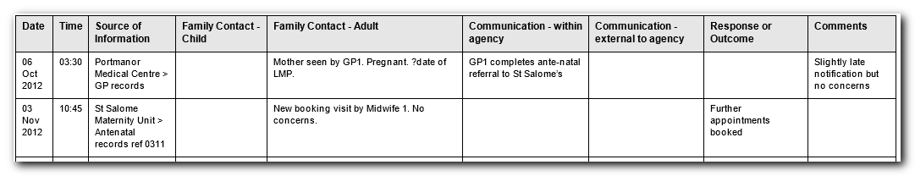

This is how they will appear in the narrative when various option combinations are used:

As in document? | Elapsed Partial? | Elapsed Full? | Print column headings? | Result
Yes | No | No | Yes | 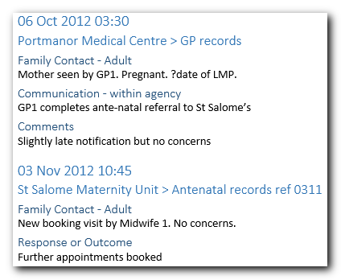
Yes | No | No | No | 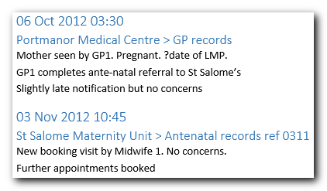
Yes | No | Yes | No | 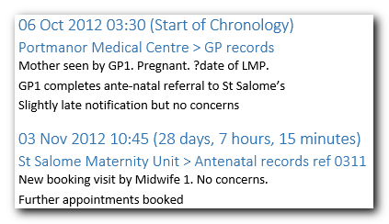
Yes | Yes | No | No | 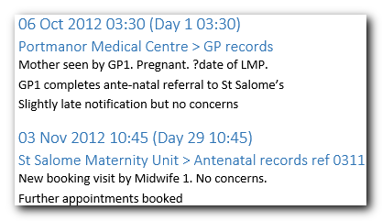
No | Yes | No | No | 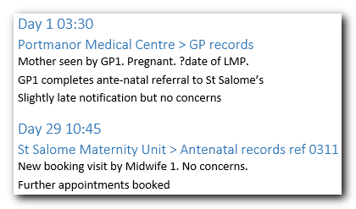
No | No | Yes | No | 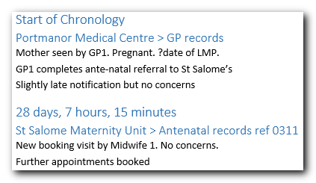

Add-ins
If there is something extra you would like Chronolator to do, please contact us to discuss the possibility of implementing it in an add-in.
Requests for new features have previously taken a long time to fulfil owing to the complexity of incorporating them and then testing the whole product. Add-ins allow feature requests to be satisfied more quickly.
Chronolator Add-ins are Word templates (dotm files). They should not be confused with the Add-ins tab on the Word Ribbon.
If a Chronolator Add-in is likely to be useful to a wide audience, it will be published on the Chronolator web site. Links to available add-ins will be provided at www.chronolator.co.uk/download.htm.
Add-ins include detailed instructions about how to use them. The rest of this section gives brief instructions about how to use a typical add-in, in this case called c8Addin03Timeline03.

Loading an add-in
The first step is to load the add-in into Word. Press Tools > Add-ins > Load add-in: | 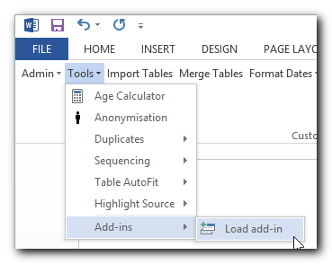
Word’s Open dialog will appear. Navigate to and open the add-in: | 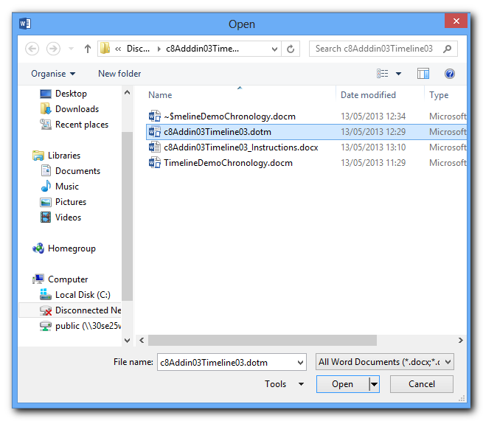
Message 8000 confirms the add-in has loaded: | 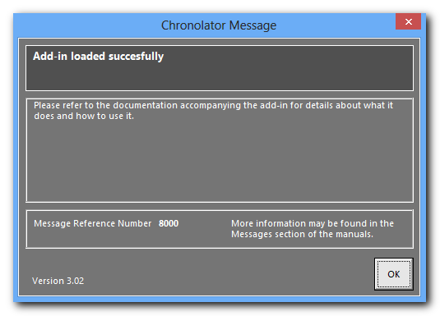
Press OK to dismiss the message.

Using an add-in
After an add-in has loaded, it updates the Tools > Add-ins menu with its functions. In this case, the add-in has provided a Create Timeline option:  Add-ins are supplied with their own detailed instructions. | 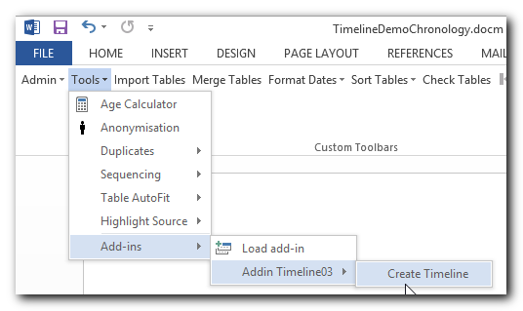

Document Details and System Information Reports
The Document Details and System Information reports give information about the chronology document and the Word and operating system environment in which it is running.

The Document Details report
The Document Details report contains information about the internal structure of the document (such as what columns are included, whether they are mandatory and so on), and statistics about the tools used while editing it.
Press Admin > Show Document Details:  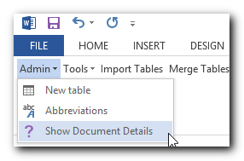 | The Document Details report is displayed. Note the vertical scroll bar that allows you to page through it. A horizontal scroll bar will also appear if necessary, as shown here.  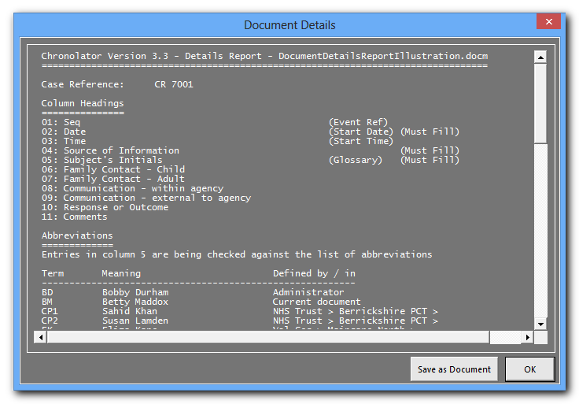
Press OK when you have finished looking at the report, or if you want to copy the information to a new document, press Save As Document.
The various sections of the report are described below.

Case Reference
The Case Reference assigned by the Case Review Administrator.

Column Headings
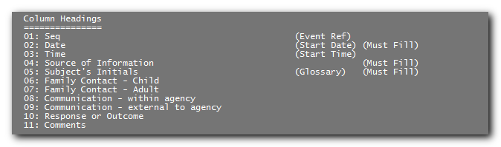
A list of the headings for each column in the chronology table, identifying any Special Columns (see Special columns on page 27).

Abbreviations
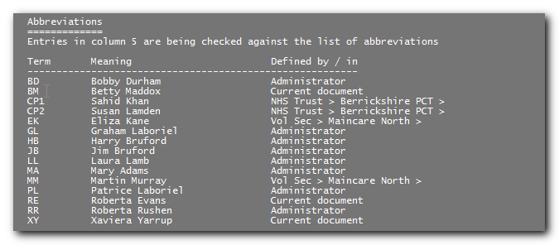
The entries in the Abbreviations Glossary, showing where they were defined and whether they are being used during Chronolator error checking.

Source Prefixes
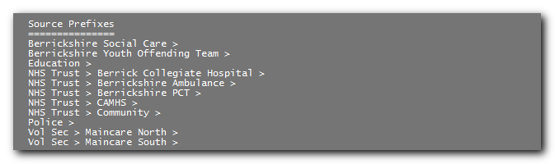
The Source Prefixes in a Composite Chronology, assigned when importing other chronology documents.

Miscellaneous
The order chosen when tables were last sorted, how many Chronolator tables are in the document, and how many events are in the chronology.

Statistics
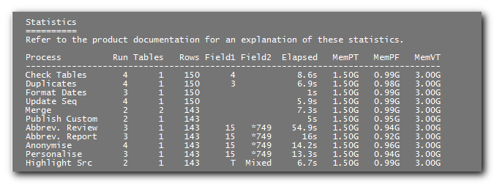
Statistics about the tools used.
The Run column records how often the tool has been used.
The remaining columns relate to the last time the tool was used, and are described below.

Tables | How many tables were in the document when the tool was started.
Rows | The number of events in the chronology tables (excludes the table headings).
Field 1 | Check Tables The number of errors found.  Duplicates The number of duplicates found.  Format Dates Not used.  Update Seq Not used.  Merge Not used.  Publish Custom Not used.  Abbrev. Review the number of glossary entries which were searched for.  Abbrev. Report "  Anonymise "  Personalise "  Highlight Src Scope (T= Text, CT=Cell Text, RT=Row Text, C=Cell, R=Row).
Field2 | Check Tables Not used.  Duplicates Not used.  Format Dates Not used.  Update Seq Not used.  Merge Not used.  Publish Custom Not used.  Abbrev. Review The number of glossary entries which were found. If preceded by an asterisk, the Glossary column was included in the search.  cncl means the user cancelled the process.  Abbrev. Report "  Anonymise "  Personalise "  Highlight Src Colour Scheme (in full, except TxtWhi=Text on White, C&G=ColoursAndGreys).
Elapsed | Time taken.
MemPT | Total physical memory on computer.
MemPF | Free physical memory on computer.
MemVT | Total virtual memory on computer.

Software Versions used
The versions of Word and Windows used to produce the document. In a Composite Chronology, an asterisk preceding the version information means that that version was used for one of the imported chronologies.

System Processors used
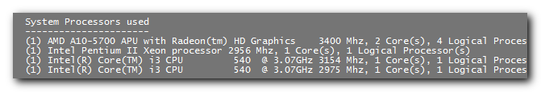
The System Processors (CPUs) used to produce the document. The number in brackets at the start of each line is the number of physical processors on the machine.

The System Information report
The System Information report contains information about the Word and Windows versions on a computer.
Press Help > About Chronolator: | 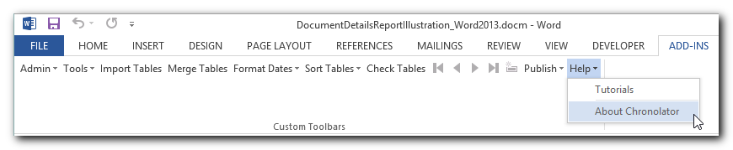
Press the System Information button: | 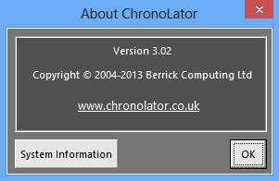
The System Information report is displayed. Note the vertical scroll bar that allows you to page though it. | 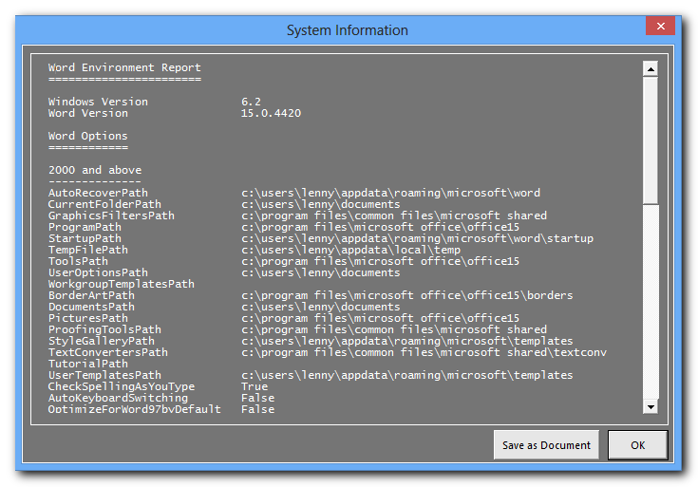

Press OK when you have finished looking at the report, or if you want to copy the information to a new document, press Save As Document.

Hidden macros
All the tools you usually need are on the Chronolator toolbar. However, there are some special commands which are only available using Word’s standard Run Macro facility.
Note: You should usually only run these macros if asked to do so by Chronolator support staff.
In Word 2003, you run a macro by pressing Tools > Macro > Macros. . . | 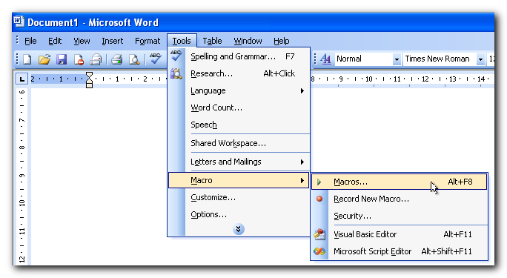
In Word 2007 and later versions, you run a macro by pressing Macros on the Developer tab of the ribbon:  The Developer tab is only shown on the Ribbon if Word Options > Customise Ribbon > Developer is ticked: | 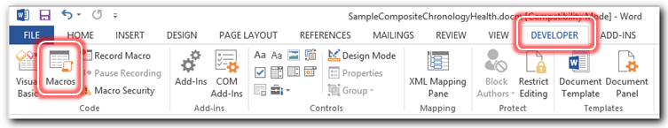  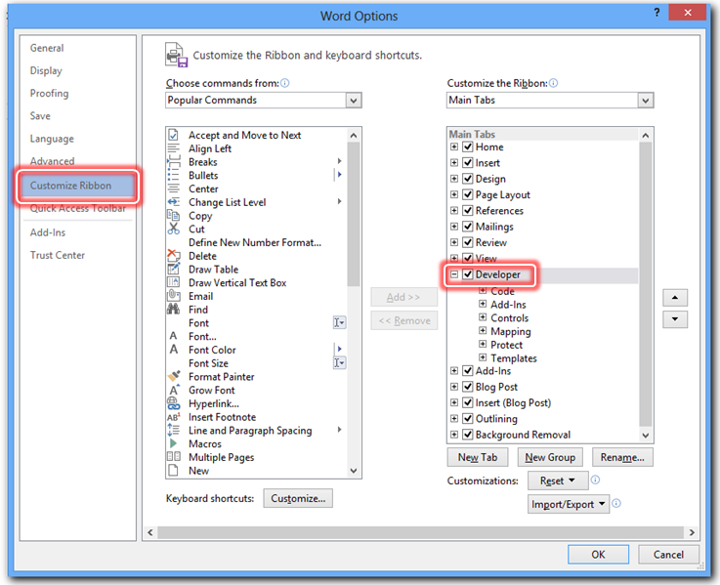
In all versions of Word, you will be asked which macro you want to run as shown here.  Select the macro and press Run. | 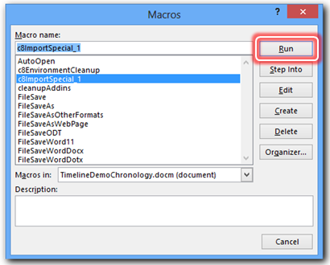

Importing a document without adding a Source Prefix
Macro c8ImportSpecial_1 imports a document as-is without adding a prefix to its Source of Information column.

Cleaning up the Chronolator environment
Chronolator stores some settings in the user area of the Windows Registry, and sometimes saves your work in hidden Word documents. It removes these things when the last Chronolator document in a Word session is closed. If this removal were to fail (if Word crashes for example) it might affect opening the next Chronolator Document.
Macro c8EnvironmentCleanup performs the same clean-up that Chronolator does when it closes normally.

Unloading Chronolator Add-ins
The last Chronolator Document to be closed in a Word session should unload any Chronolator Add-ins. If it fails to do so, you can run macro cleanupAddins, which will unload Chronolator Add-ins but leave any others you might use in place.

Working with Microsoft Word tables
This section provides some hints and tips about working with tables in Microsoft Word. Generally it gives only one way of achieving a particular end, but there are often other ways. You can find more information in Word’s Help, particularly under ‘Keyboard Shortcuts’.
It is always worth experimenting and asking colleagues for tips. You might feel that you do not have time to do so, but ten minutes spent once in a while to find a new time-saver can save you much more than that over the years.

Terminology
Tables are composed of a number of Rows and Columns. Each individual ‘box’ where a row and column meet is called a Cell.

Using a mouse
As you move the mouse over a table, the pointer changes. Sometimes it points upwards from left to right, sometimes from right to left, sometimes it is the insertion pointer, sometimes a width adjuster, and sometimes a black arrow. What happens when you press the mouse depends on what the pointer looks like.

Figure 5 - mouse pointer shapes

Selecting items in a table
If you want to move or copy an item in a table, you must first Select it. Word highlights whatever is selected.
You can select items with the Mouse or with the Keyboard.

Selecting items with the mouse
The table below shows how to select table items with the mouse.
Be careful, because if you move the mouse while you are pressing it the effect can sometimes be different to what you want as the pointer changes.
Also, note that there is a difference between selecting the text in a cell and selecting the cell itself.

Item to be selected | Mouse pointer | Mouse action
Text in a cell |  | Press and hold at beginning of text, drag to desired end, let go.
Cell |  | Press left edge of cell.
Row |  | Press to left of row.
Column |  | Press top edge of column.
Multiple elements |  | Press as above and drag across the table as desired.

Selecting items with the keyboard
The table below shows how to select table items with the keyboard.

Item to be selected | Key
Text in the cell to the right | Tab
Text in the cell to the left | Shift +Tab
Multiple elements | Shift + Arrow keys (experiment!)

Adding rows to a table
To add a row to the end of a table, press the mouse anywhere in the bottom right hand cell and press the Tab key.
To add a single row in the middle of the table using Word 2003 and earlier, select the row above which you want it to go, right-click the mouse, and press Insert Rows.
To add a single row in the middle of the table using Word 2007 and later, press in the row next to which you want it to go, right-click the mouse, press Insert, and choose whether to insert Above or Below.
To add several rows to the middle of the table, select the desired number of rows next to which you want the new rows to go, right-click the mouse, and press Insert Rows (2003 and earlier - the rows will be inserted above) or Insert (2007 and later - choose whether Above or Below). The number of rows you selected will be added.

Copying and Moving items in a table
When you have selected an item by one of the methods described above you can copy or move it to another place with the Mouse or with the Keyboard.

Copying and moving items with the mouse
Use Windows ‘Drag and Drop’. To Move an item, just do the following;
- Move the mouse over the selection until the pointer is an arrow pointing upwards from right to left like this ;
- Press and hold the left mouse key;
- Move the mouse pointer where you want the item to go;
- Let go of the left mouse key.
If you want to Copy instead of Move, hold the Ctrl key while you do the above.

Copying and moving items with the keyboard
Use the Windows Clipboard shortcut keys to copy the selected item to the Clipboard:
- Ctrl + C to copy and leave in place;
- Ctrl + X to cut from the current location.
Move the Insertion Point to the desired location, and press Ctrl + V to paste the Clipboard into the new location

Undoing mistakes
Because of the many types of table elements you can select, it is easy to make a mistake. If you want to undo a mistake, you can press the mouse on the Undo button on Word’s Quick Access Toolbar (in Word 2003 or earlier, the Standard toolbar), or press Ctrl + Z on the keyboard.

Appendix A – Troubleshooting
If your problem is not described here, please see the FAQ page on the Chronolator website www.chronolator.co.uk/faq.htm, which contains information about problems encountered after this document was produced.
Many of the actions described below depend on what version of Word you are using. If you are unsure, refer to How can I tell which version of Word I am using? on page 14.

The Chronolator toolbar does not appear
The Chronolator toolbar should appear below your other Word toolbars in Word 2003 and earlier versions. In Word 2007 and 2010, it should be added to any other custom toolbars on the Add-Ins tab on the Ribbon.
There are two reasons why this might not happen:
- Your security settings are too restrictive – see Security Settings below;
- Your Chronolator licence has expired – see Expired Licence on page 94.

Security settings
If you are using Word 2000, XP, 2003, or 2007, please skip to Macros on page 87.

Protected View (Word 2010 and Word 2013)
As well as the security settings for running macros which are described below, Word 2010 and Word 2013 sometimes open a document in Protected View, in which no editing is allowed. You must enable editing if you want to make any changes to the document or use its Chronolator facilities.

If you get a warning like this, press Enable Editing.
Skip to Macros on page 87.
If you get a message like this, press it to discover more information.
The resulting display tells you more about why Word stopped you editing the document and offers the opportunity to change some settings.  In this example, you would press File Block Settings . . . | 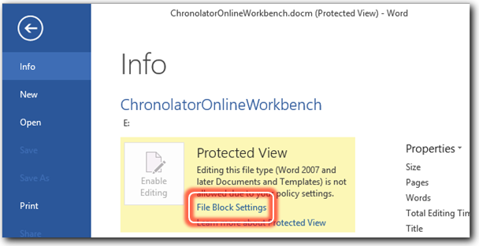
. . . and then:  press the circle next to Open selected file types in Protected View and allow editing;  press OK a few times until you return to the Chronolator document;  close and reopen the document;  press Enable Editing as shown in the picture on page 84. | 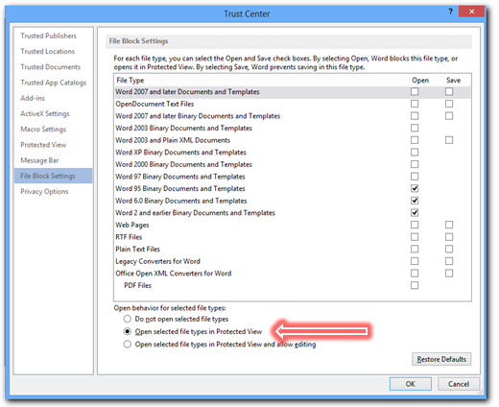

The File Block settings in the above example are just some of those which can make a document open in Protected View. Other settings which activate Protected View can be found in the Trust Center (see the instructions on page 89 for information about opening the Trust Center).
The Trusted Locations, Trusted Documents, and Protected View buttons work together to influence when a document opens in Protected View. | 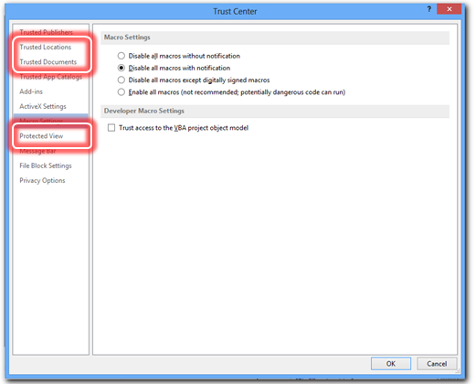
To find out more information about the settings you can make after pressing one of these buttons, press ? at the top right hand corner to open Word Help for the relevant topic. | 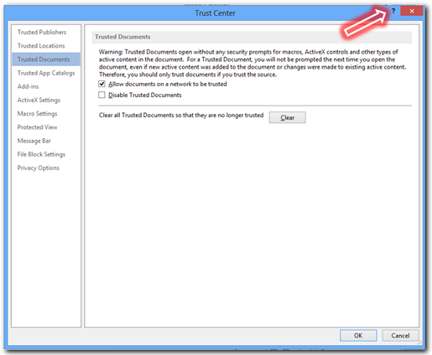

Once your document is open in an ordinary view rather than Protected View, you will need to ensure macros can run: read on!

Macros
Chronolator works by running macros in the background. Some documents that contain macros can harm your computer, so Word allows you to control whether or not they run.
If the Chronolator toolbar does not appear, your Word security settings are probably too restrictive. Following the instructions given here will ensure that Chronolator can run without compromising your computer security.
How to set your macro security levels depends on your version of Word.
Follow the instructions for your version (Word 2003 and earlier versions below, or Word 2007 and later versions on page 88), or view one of the videos about Running Macros at www.chronolator.co.uk/tutorials.

Word 2003 and earlier versions
We recommend that you set your macro security level to Medium; Word will then ask you whether you want to run macros whenever you open a document that contains them.
The pictures below show how to set your security levels in Word 2003. Earlier versions of Word might use slightly different menus and security levels.

Press Tools > Macro > Security. | 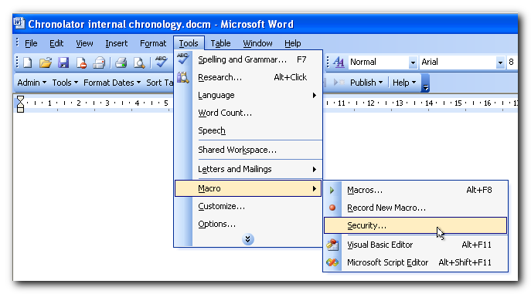
On the Security Level tab, set the level to Medium.  Press OK. | 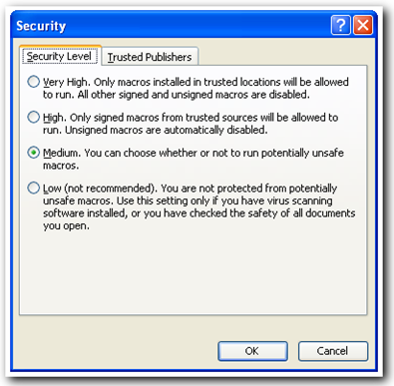

The change will not take effect until the next time you start Word.
Close ALL Word documents, and then reopen the Chronolator document.
Because the settings are not changed until Word restarts, you might confusingly get the following message while closing the documents. Just press OK.
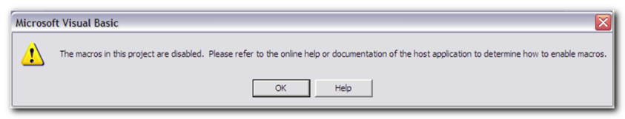

Word 2007 and later versions
When you open a Chronolator document in Word 2007, the area under the Ribbon might display a warning message like the one to the right.  If so, skip to Word 2007 displays ‘Security Warning Macros have been disabled’ on page 92. | 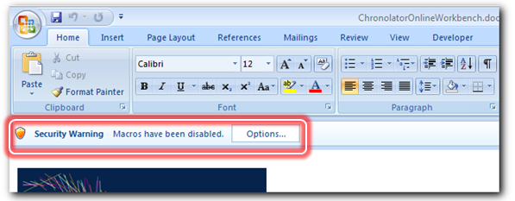
In Word 2010 and Word 2013, the equivalent message is like this.  Skip to Word 2010 and later versions display ‘SECURITY WARNING Macros have been disabled’ on page 93. | 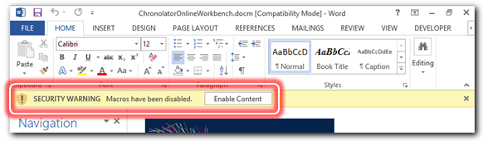
On the other hand, Word 2007, Word 2010 or Word 2013 might disable macros without telling you. There is nothing between the Ribbon and the document, as shown here.
If so, continue following these instructions.

Word 2007 and later versions do not display any warning about macros
If no macro warning is displayed you need to set some options in Word’s Trust Center:
- First of all, open the Word Options dialog. How to do this is slightly different for each Word version. Read the appropriate section below;
- After opening the Options dialog, carry on reading at Trust Center Settings on page 90.

Opening the word Options dialog in Word 2007
Press the button in the top left corner of the display and then press Word Options. | 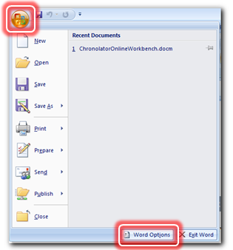

Opening the word Options dialog in Word 2010
Press the File tab, then press Options. | 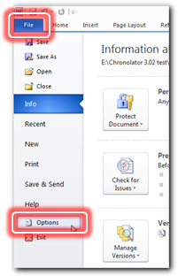

Opening the word Options dialog in Word 2013
Press the File tab. | 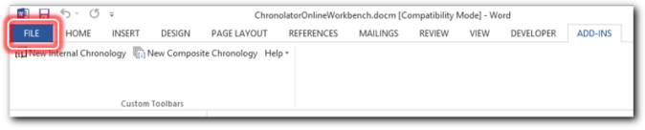
Press Options. | 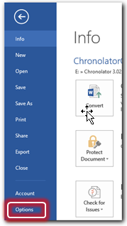

Trust Center settings
In the Word Options dialog, press Trust Center, then press Trust Center Settings. | 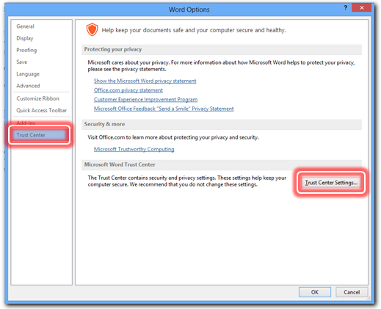
Press Macro Settings.  Press Disable all macros with notification.  (Somewhat confusingly, although we want to enable macros, we have to disable them with notification). | 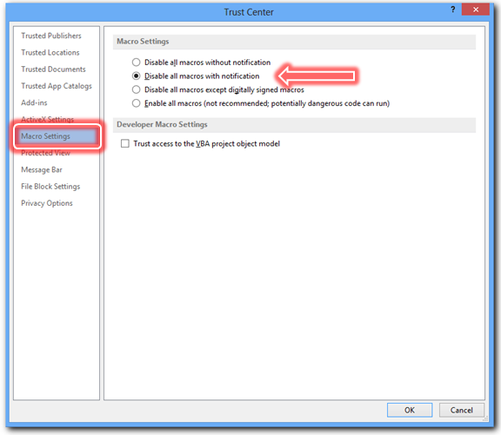
Press the Message Bar button.  Press Show the Message Bar in all applications … | 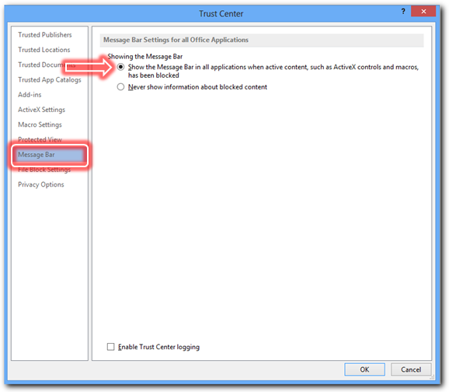
Press OK a few times until you return to the Chronolator document.
Close and reopen the Chronolator document. Word will now display a Security Warning telling you it has disabled macros; see Word 2007 displays ‘Security Warning Macros have been disabled’ below or Word 2010 and later versions display 'SECURITY WARNING Macros have been disabled' on page 93 to see how to deal with it.

Word 2007 displays ‘Security Warning Macros have been disabled’

Press the Options button next to the warning.

The dialog box to the right will appear.  Press Enable this content.  Press OK. | 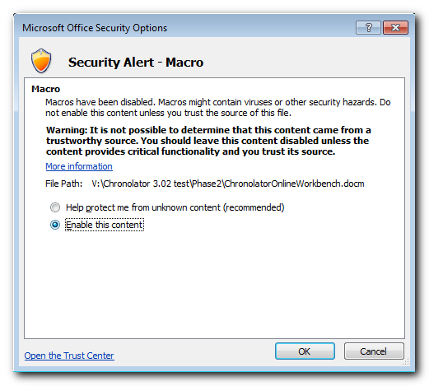
Macros are now enabled.
Chronolator will ask you to accept the terms of its licence.
Press OK.
The Chronolator toolbar will appear on the Add-Ins tab as shown here. | 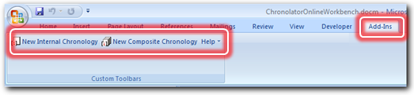  This is the Online Workbench toolbar. Toolbars in other Chronolator documents have different buttons.

Word 2010 and later versions display ‘SECURITY WARNING Macros have been disabled’

Press Enable Content.
Macros are now enabled.
Chronolator will ask you to accept the terms of its licence.
Press OK.
Word might ask if you want to ‘make this file a Trusted document’: | 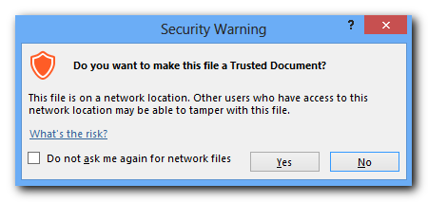
If you answer Yes macros will automatically be enabled whenever you open this document in future. It is usually safe to do this, but you should be aware of the advice Microsoft give in their Help: | 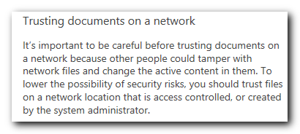
Whatever you decide, the Chronolator toolbar will appear on the Add-Ins tab as shown here. | 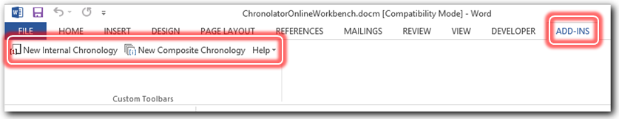  This is the Online Workbench toolbar. Toolbars in other Chronolator documents have different buttons.

Expired Licence
You must have a valid licence to run Chronolator. If you do not have one it will tell you so when it starts.
All standard Word features continue to work after the licence has expired, but you will not get any Chronolator toolbar.
More details about licensing are in Appendix C – Licensing on page 140.

The Chronolator toolbar has disappeared
If the Chronolator toolbar was there when you opened the document but is no longer visible, you might have hidden it by accident.
In Word 2003 and earlier versions, you might have pressed the Show Only Web Toolbar button to the right of the ‘Go’ button on the Web toolbar:
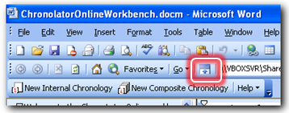
Press it again to show all toolbars.

In Word 2007 or later versions, you might have minimised the Ribbon. If so, click the Add-ins tab to show the Chronolator toolbar.
You can maximise the Ribbon if you want it to stay visible. Right-click between any of the tab labels (Home and Insert for example) and un-tick Minimise the Ribbon or Collapse the Ribbon:
Word 2007 | Word 2010 | Word 2013
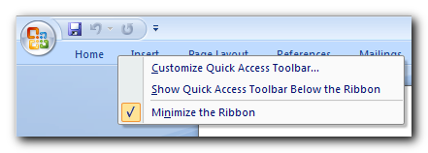 | 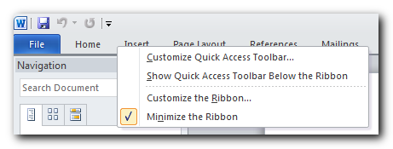 | 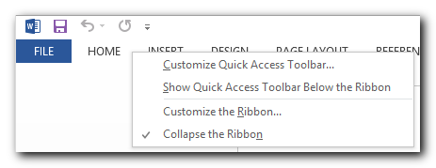

The Chronolator toolbar doesn’t have all its buttons
Chronolator only puts buttons on the toolbar if they can do something useful in the current document - for example, since the only thing you can do with a fresh Composite Chronology is to import tables into it, the only buttons are Import Tables and Help.
Having said that, Word hides buttons from the toolbar or ribbon if your window is too small. To get them back, just widen or maximise the window.

The Chronolator progress bar disappears
Chronolator informs you about the progress of most tasks using the Progress Bar. For example, while you are checking tables it might look something like this: | 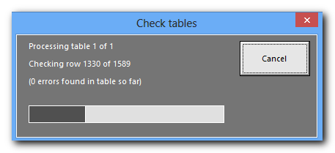
Sometimes, if you are processing a very large file on an older computer with not much memory, or on a slow network, the progress bar can disappear from time to time. If this happens, it is often possible to make it visible again by double-clicking on the document's icon in the Windows Task Bar.
In any case, disappearance of the progress bar does not affect the processing which is being done. When it has finished, Chronolator will display a completion message as usual.

Recovering corrupted Chronolator Documents
Like any Word document, a Chronolator document can become corrupted if problems occur on your computer or network while you are working on it. Symptoms can vary. For example:
- Microsoft Visual Basic messages about a ‘Run-time Error’;
- Badly formatted or corrupted tables or text;
- Word crashes or stops working.
The next few paragraphs describe what you can do to try to recover them.

Run-time Errors

Chronolator uses macros and variables which are hidden inside the document. If they become corrupted, you might get a message similar to this:  The actual ‘Run-time error’ number and description can vary. | 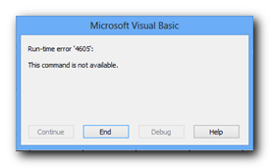

To recover from this, you will need a blank Chronolator Document. If you still have the original which was sent to you, you should use that. If not, contact the person who sent it to you and ask for another copy.
- Open the blank Chronolator Document.
- Use Word’s Insert File tool:
In Word 2003 and earlier versions, this can be found by pressing Insert > File. | 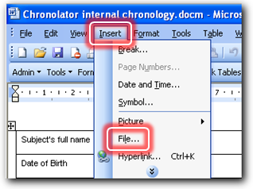
In Word 2007 and later versions, press the Insert tab on the Ribbon, and then Object > Text From File. | 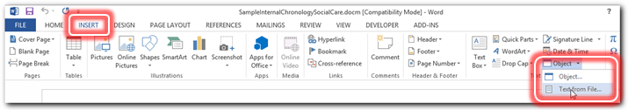

- Navigate to and select the corrupted document and press Insert. | 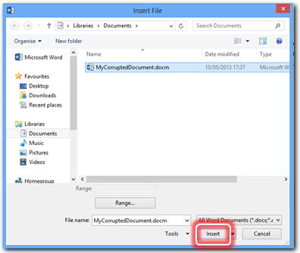
- Save, close and re-open the document.

- If the document is OK when you re-open it, you have successfully recovered your document and can carry on with your work.
- If not, or if the Insert fails:
- follow the instructions in the next section Corrupted tables or text;
- go back to Step 1 above. In Step 3, insert the file you will have created in the next section.

Corrupted tables or text, or Word stops working
If the tables or text in the document have become corrupted, or Word stops working, try using Word’s Open and Repair facility, which is available from Word’s standard Open dialog.

Reaching the Open dialog
Getting to the Open dialog is straightforward unless you are using Word 2013: after you have started Word, just press File > Open (or in Word 2007, > Open button).
In Word 2013, you need to fiddle about a bit. Here is one way to do it:
Press the File tab.
Press Open, then Computer, then Browse. | 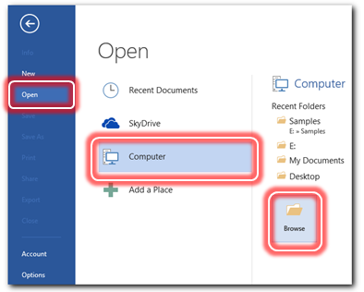

Using Open and Repair from the Open dialog

Navigate to the corrupted document, but do not left-or double-click on it; if you do, it will open without giving you the opportunity to repair it.  Right-click on it to select it, and then:  - press the small arrow to the right of the Open button;  - press Open and Repair.  The options you see when pressing on the downward arrow will vary depending on your version of Word. | 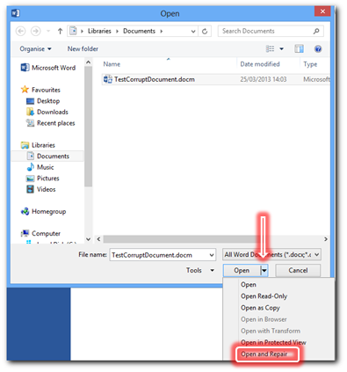
Word will try to recover your file. If it succeeds, it will display a list of any problems it has corrected.  Close the list and save the file. | 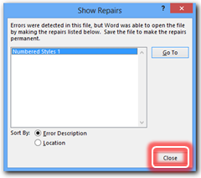

Slow processing
If you find that Chronolator is running unusually slowly, it can sometimes help to close Word and start again - don't forget to save your work first!
For example, on one occasion while Version 3 was being developed, it was found that updating sequence numbers in a large file was taking almost four minutes. After saving, closing, and re-opening the document, the time went down to just over one minute.

Conflicts with other Word add-ins
Sometimes other Word add-ins conflict with Chronolator. When that happens, you can start Word without loading add-ins and then open the Chronolator Document from Word's Open dialog.

Starting Word without loading any add-ins
One way to do this is described below. The information was taken from an article on Microsoft's web site: http://support.microsoft.com/kb/210565.
Locate the Windows key near the bottom left of your keyboard: | 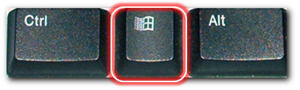
Hold down Windows and press R to open the Run dialog: | 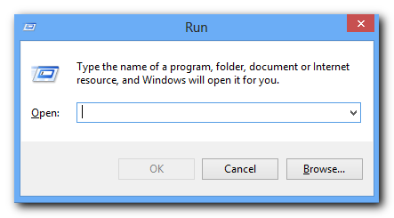
Press the Browse … button.  Word's Browse dialog will be displayed.  Find Winword.exe. | The default locations are as follows:  Word 2013 C:\Program Files\Microsoft Office\Office15  Word 2010 C:\Program Files\Microsoft Office\Office14  Word 2007 C:\Program Files\Microsoft Office\Office12  Word 2003 C:\Program Files\Microsoft Office\Office11  Word 2002 C:\Program Files\Microsoft Office\Office10  Word 2000 C:\Program Files\Microsoft Office\Office
In the Browse dialog, click Winword.exe, and then press Open: | 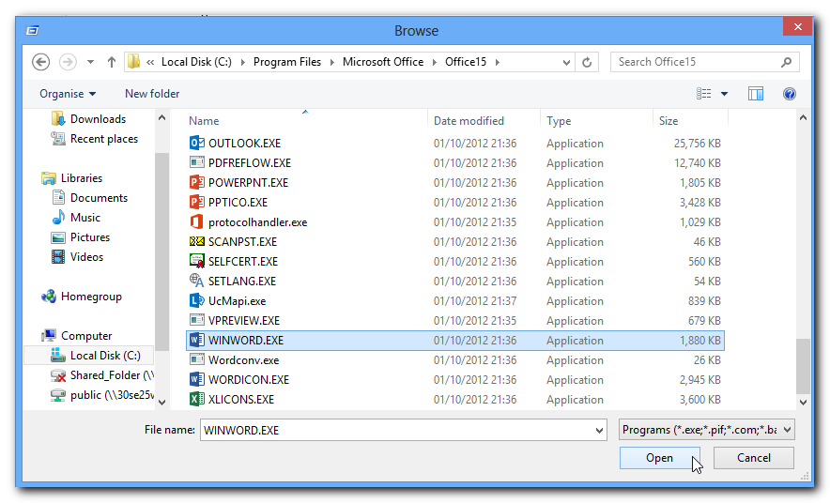
The Run dialog will be redisplayed, with the path to Winword.exe in the Open box, surrounded by quote marks: | 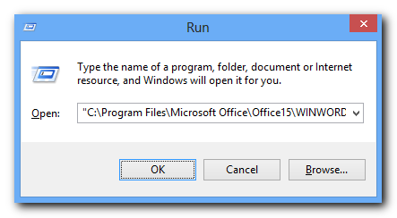
Click in the Open box, reposition the insertion point to the right of the closing quotation mark at the end of the path statement, and type a space followed by /a | 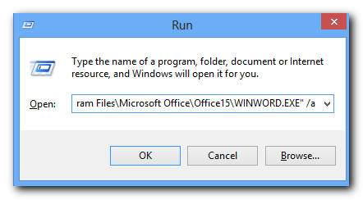
Press OK to open Word | Word will start without any add-ins.

Now open the Chronolator Document from Word's Open dialog.

Appendix B – Chronolator messages
Chronolator messages fall into two main groups:
- Messages confirming the results of some processing or offering the user a choice of actions. These messages are displayed on the Chronolator Message Form and have unique reference numbers. They are described in the next section;
- Brief messages describing errors found when checking tables. These messages appear as Tooltips when the mouse is hovered over a table error, and are also listed at the bottom of a Chronolator Document after Check Tables discovers errors. They are described in Check Table Error Codes on page 137.

Message Form Messages

The Message Form
The Chronolator Message form has three main parts:
The upper part contains the main message.
The middle part contains a more detailed explanation of the message, and suggests what actions might be appropriate.
The lower part displays a four-digit Message Reference Number, which can be used to locate the message in the following sections.

All the messages are shown below, together with further information and suggested actions if appropriate.

Messages 1000 – 1999
Messages in this range are issued when importing, merging and sorting tables.

1000 | Tables imported
 | All Chronolator tables have been imported. You can merge them into a single table by using the 'Merge Tables' button on the Chronolator toolbar.
Further Information | Chronolator has imported tables from one document into another. The imported tables appear after those which were originally in the target document.  You can continue importing more tables, or merge the tables together.

1003 | Invalid document
The file you chose is not a Chronolator document and cannot be imported into a new Composite Chronology.
Please refer to the description of this message in the documentation for suggestions about what to next.
Further Information | A new Composite Chronology has no information about the requirements for a particular review until you import a Chronolator Document.  Once this information is in place, Chronolator will import matching tables from any Word document; but the first document you import into a blank Composite Chronology MUST be a Chronolator Document.

1005 | Case References are different  Composite Chronology: CaseReference1  Imported Chronology: CaseReference2
 | Press OK to continue with import, or Cancel
Further Information | Every Chronolator Document is assigned a Case Reference by the Case Review Administrator in order to warn against accidentally merging documents which relate to different cases. The Case Reference of each document is shown in the message.
Possible causes | You are trying to import tables from a non-Chronolator document, or from a Chronolator document which has a different Case Reference.
Possible actions | Press OK if you want to continue with the import, or Cancel if you do not.

1010 | 'Must-fill' columns are different in source and target documents
 | Press OK to continue with import, or Cancel
Further Information | Although Chronolator has found tables which have the correct column headings, the ‘Must-fill’ columns are different.
Possible causes | You are trying to import tables from a non-Chronolator document, or from a Chronolator document from a different case which has different ‘Must Fill’ columns.
Possible actions | Press OK if you want to continue with the import, or Cancel if you do not.

1015 | No Data Tables found in document
 | There are no tables in the document which match the required column headings.
Further Information | Issued when you process a document which has no tables with the required column headings.
Possible causes | If you are checking, sorting, or formatting a document, the table headings might have been accidentally changed.  If you are importing a document, the headings in the document you are trying to import do not match those in the composite.
Possible actions | Check what column headings Chronolator expects, and if appropriate change table headings in the problem document to match the defined headings.  You can find the expected headings by using the Admin > Show Document Details button.  Alternatively, use the Admin > New Table button to add a table with the correct column headings to the bottom of the document. After you have done so, either copy any data you have already entered into the new table, or copy the heading row from the new table into that of the old one.

1020 | Document level mismatch
The document you are trying to import cannot be imported into this document as it was created with a higher level of Chronolator.
Create and use a new Composite Chronology using the higher level document for this review. Refer to the manuals if you require step-by-step instructions.
Further Information | Chronolator documents are generally backwards-compatible; that is, newer version documents can read older version ones. However, it is not possible to guarantee forwards-compatibility.

1025 | Conflicting and Multiple Definitions
The document you are trying to import includes some abbreviations and definitions which could be confused with those in this one. Although Chronolator will keep track of what was defined where, reading the document might be confusing
If you want to use the anonymisation / personalisation feature in the Composite Chronology, you must first resolve these conflicts by changing the abbreviations in one of the documents.
Press Go To List to review the conflicts, OK to continue with the import, or Cancel.
Further Information | Chronolator will import a document with conflicting and multiple entries in the Abbreviations Glossary, but if you want to anonymise or personalise the document you must resolve these anomalies. You will be able to do this in the Composite Chronology after import, but it is recommended that you do it in the source document before importing it.

1026 | Conflicting Definitions - Import Cancelled
 | You have chosen to save the conflicting definitions in a new document. Chronolator assumes this is because you want some time to review them, and will therefore cancel the Import.
Further Information | Issued if you press Go To List in response to Message 1025.

1030 | User-defined sequence column found
The document you are trying to import includes a user-defined Sequence column. It was probably added because the person completing the document wanted to be exact about the order of certain events whose exact times were unknown. Chronolator can either add a Sequence column to the table(s) in this document, or delete the one in the document being imported.
Press Add to add a Sequence column to the table(s) in this document, Delete to delete the one in the document being imported, or Cancel.
Further Information | Recommendation: Press Add to add a Sequence column to the Composite Chronology so that you can continue to preserve the correct order of events. After you have done so, you can use the Tools > Sequencing menu to add numbers to the remaining events.  If you choose Delete, the Sequence column remains in the document being imported but is not carried across.

1031 | Sequence column not found
The document you are trying to import does not include a Sequence column, but is suitable for import in all other respects. Chronolator can either delete the Sequence column from the table(s) in this document, or add one to the document being imported.
Press Add to add a Sequence column to the table(s) in the document being imported, Delete to delete the one in this document, or Cancel
Further Information | Recommendation: Assuming you have deliberately added a Sequence column to the Composite Chronology, press Add to add one to the document being imported (the document itself is unchanged, just the version of it in the Composite Chronology). After you have done so, you can use the Tools > Sequencing menu to add numbers to the imported events.

1033 | Unable to import
Chronolator cannot import anything into this document because of the following internal inconsistencies in its structure:
list of inconsistencies
Further Information | The document you are trying to import is a Chronolator Document, but it has some internal inconsistencies. These are listed in the message.
Possible causes | The internal variables which Chronolator uses to describe the document structure have been lost or corrupted. This can sometimes happen when importing documents across a slow network, or it might happen if Word failed while the document was being edited some time in the past.
Possible actions | - if the document is on a slow network, copy it to your desktop and try importing the copy;  - try Repairing the document as described in Recovering Corrupted Chronolator Documents on page 96.

1100 | Tables merged
 | All Chronolator tables have been merged into a single table. You can sort the new table into the correct sequence by using the 'Sort Tables' button on the Chronolator toolbar.
Further Information | Chronolator has merged all the tables in the document.  The next thing you might want to do is to sort the events into chronological order.

1105 | Cannot merge tables
At least one of the tables in this document has a row with the wrong number of columns. Please correct this and try again.
Hint: Use Check Tables to find the problem.
Further Information | Chronolator has found a table which, although it has the correct headings, contains at least one row with the wrong number of columns.
Possible causes | Cells have been merged.  A row has been added with the wrong number of columns.
Possible actions | Open the offending document and press Check Tables. Chronolator will correct any rows with the wrong number of columns and highlight them. You should check that Chronolator has put the relevant information in the right columns before saving the corrected document.

1110 | Cannot merge tables
 | A non-Chronolator table has been found in between the Chronolator tables. The offending table is selected. Please move or delete it and try again.
Further Information | The document contains more than one Chronolator table, and among them is a non-Chronolator table.
Possible causes | An ordinary Word table has been inserted by accident.  A Chronolator table has had its headings changed.
Possible actions | If the table contains no data for import, delete it or move it to the end of the document.  If the table does contain data for import, correct its headings so that Chronolator recognises it as a Chronolator table.

1120 | Multiple chronology tables found
This document contains more than one chronology table.
Press 'Merge' if you want Chronolator to merge the tables and sort them before processing.
Press 'Don't Merge' to process each table individually.
Press 'Cancel' to return to the document without doing anything.
Further Information | It is normal to have multiple chronology tables when assembling a Composite Chronology, but in other circumstances it might come about by accident. Chronolator therefore checks how many tables are in a document before most major processes, and if there are more than one if offers to merge and sort them before continuing.

1200 | Table sorted
Events should now be in Date and Time sequence.
Some date and time formats can prevent a successful Sort. If that happens, use the Format Dates button to put dates in the all-digital format and then sort the table again. You can put the dates back to your preferred format afterwards if you wish.
If you know the order of events on a day but not exactly when they occurred, you can use a Sequence column to put them in order. You can make one using the Tools > Sequencing > Add Column button.
Further Information | Chronolator puts events with unspecified Times or End Dates before those specified with greater detail if the sort is Ascending, or after them if it is Descending.  See Using a Sequence column on page 59 for details about using a Sequence column.

1201 | Table sorted
Events should now be in Date and Time sequence.
Some date and time formats can prevent a successful Sort. If that happens, use the Format Dates button to put dates in the all-digital format and then sort the table again. You can put the dates back to your preferred format afterwards if you wish.
If you know the order of events on a day but not exactly when they occurred, you can use the first column to put them in order.
Further Information | Chronolator puts events with unspecified Times or End Dates before those specified with greater detail if the sort is Ascending, or after them if it is Descending.  See Using a Sequence column on page 59 for details about using a Sequence column.

1300 | Dates formatted
All dates have been formatted to one of Chronolator's standard formats.
If you would like future releases of Chronolator to offer alternative date formats please use the suggestion form on our web site www.chronolator.co.uk.
Further Information | Chronolator uses two main formats for dates:  - dd mmm yyyy (e.g. 01 Feb 2005). This format takes up a small amount of space while being unambiguous about months and days (compared to, say 01.02.05 – is that the first of February or the second of January?);  - yyyy-mm-dd (e.g. 2005-02-01). This is the ISO 8601 format. It takes even less space than the previous format and has the advantage of being an International Standard, but most people find it harder to read.  The day of the week can be added to both of these formats.  If you would like to be able to set other formats, please contact us via our web site.

Messages 2000 – 2999
Messages in this range are issued by the Online Workbench.

2000 | Cannot find Master Chronology Document
 | Find the file < ChronolatorMasterChronology.docm > from your original Chronolator installation and copy it into folder folderName.
Further Information | When you create a new Chronology Document, Chronolator looks for the file ChronolatorMasterChronology.docm. It issues this message if it cannot find it.
Possible causes | You have opened the Online Workbench directly from the installation zip file. You need to Extract All Files from the installation file and open the extracted Online Workbench.  The Master Chronology document has been moved or deleted.  The Online Workbench has been moved, but not the Master Chronology.
Possible actions | Extract All Files from the installation zip file.  Find the file ChronolatorMasterChronology.docm and copy or move it into the folder shown in the message.

2001 | Cannot copy Master Chronology Document
 | The Master Chronology Document (ChronolatorMasterChronology.docm) is open and cannot be copied. Please close it and try again.
Further Information | When you create a new Internal or Composite chronology, Chronolator tries to open ChronolatorMasterChronology.docm. It issues this message if the file is already open.
Possible causes | You have opened ChronolatorMasterChronology.docm.
Possible actions | Close ChronolatorMasterChronology.docm and try again.

2002 | Master Chronology Document is wrong version
 | The Master Chronology Document (ChronolatorMasterChronology.docm) is the wrong version for this Online Workbench. Please copy the correct Master Chronology into folder folderName.
Further Information | When you create a new Internal or Composite chronology, Chronolator opens ChronolatorMasterChronology.docm. It issues this message if the file is a different version from the Online Workbench.
Possible causes | You have upgraded the Online Workbench without also upgrading the Master Chronology.
Possible actions | Install the correct version of ChronolatorMasterChronology.docm in the folder shown in the message.

2010 | Invalid document
 | The file you chose is not a Chronolator document and cannot be used as a model. Please choose another file, or use the Chronolator defaults.
Further Information | You can only use a Chronolator document as a model for a new one.
Possible causes | You opened an ordinary Word document when choosing an existing file to use as a Model in the Case Details Wizard.
Possible actions | Use a Chronolator document as a model, or use the Chronolator defaults.

2015 | Invalid document
 | The Chronolator document you chose has internal inconsistencies and cannot be used as a model. Please choose another file, or use the Chronolator defaults.
Further Information | Information about the structure of a Chronolator Document is stored in document variables. The document you have chosen as a model has inconsistencies in this information, and it is not possible to use it as a Model.
Possible causes | Word might have ended abnormally when it last processed the document, causing internal inconsistencies.
Possible actions | Use a different Chronolator document as a model, or use the Chronolator defaults.

2016 | Invalid document
 | The Chronolator document you chose is a blank Composite Chronology and cannot be used as a model. Please choose another file, or use the Chronolator defaults.
Further Information | Information about the structure of a Chronolator Document is stored in document variables. A blank Composite Chronology does not contain these variables, and it is not possible to use it as a Model.
Possible actions | Use a different Chronolator document as a model, or use the Chronolator defaults.

2020 | Cannot write document details in preamble
The area in the Master Chronology preamble where Chronolator writes information about the headings in this Chronolator document cannot be found.
This affects only the document preamble: the table and all Chronolator features will work correctly, and it is safe to distribute the document.
Further Information | When first installed, the Master Chronology contains a bookmarked area in which Chronolator writes information about the column headings in a new Internal Chronology. That area cannot now be found.  Chronolator does not write information about the headings in the preamble, but continues to create the remainder of the Internal Chronology.
Possible causes | You have customised the Master Chronology and have deleted the area and its associated bookmark.
Possible actions | If you want Chronolator to include information about the column headings, revert to the original Master Chronology and redo your changes, being careful not to delete the relevant area and bookmark.

Messages 3000 – 3999
Messages in this range are issued when Chronolator checks the tables in a Chronology.

3000 | Errors found in document (n)
Rest the mouse over the box with a cross to see a brief description of each error.
Use the buttons on the Chronolator toolbar to go from one error to the next, or press the Go To List button to view a complete list.
When you have corrected the errors, press the Check Tables button again to remove the highlighting.
Further Information | You pressed the Check Tables button, and Chronolator has found n errors.  Errors are highlighted in Turquoise, Yellow, or Purple. You can scroll from one error to the next using the navigation buttons towards the right of the Chronolator toolbar, or see a complete list of them by pressing the button to the right of the navigation buttons.  Chronolator does not check for errors as you type, so you must Check Tables after making any corrections in order to remove the highlighting.
Possible causes | Refer to Check Table Error Codes on page 137 for information about each error detected by Chronolator.
Possible actions | No immediate action is necessary, but you should ensure that all errors are corrected before returning or publishing the document.

3001 | Some rows had the wrong number of columns - fix these first
Chronolator has corrected the number of columns in at least one row. However, it could not be sure which entry should go in which column. You should review these rows now and make sure their entries are in the right places.
It is important to do this now, because now that they have the right number of columns they will not be caught in future checks unless they have other errors.
For ease of identification, the corrected rows are displayed with white text on a purple background.

3005 | Document contains errors - do you want to close it?
Please ensure that all errors are corrected before returning or publishing this document.
Press Cancel to resume editing the document and correct them now.
Press OK to close the document and correct them later.
Further Information | Chronolator has checked the document as you closed it, and has found errors. The errors are highlighted in Turquoise, Yellow, or Purple. You can scroll from one error to the next using the navigation buttons towards the right of the Chronolator toolbar, or see a complete list of them by pressing the button to the right of the navigation buttons.
Possible causes | Refer to Check Table Error Codes on page 137 for information about each error detected by Chronolator.
Possible actions | No immediate action is necessary, but you should ensure that all errors are corrected before returning or publishing the document. If you want to correct them straight away, press Cancel. If you want to do it later, press OK.

3010 | Checked - no errors found
 | Chronolator has checked all the tables in this document and found no errors.
Further Information | You pressed the Check Tables button, and Chronolator has found no errors in this document.  The buttons on the Chronolator toolbar which can be used to scroll through errors are disabled.

3011 | No changes found since previously checked
No data table appears to have changed since Chronolator last checked this document.
Press Cancel to resume editing. Press Check to re-check the document.

3013 | Document contains text after chronology tables
The area after the chronology tables is reserved for Chronolator and will be overwritten if you continue.
Press Cancel to return to the document and review the text Chronolator found. If you want to keep it, move it before the chronology tables before you check the tables again. Press OK to delete the text and continue.
Further Information | You pressed the Check Tables or Duplicates button. Chronolator will overwrite whatever follows the chronology tables in the document if you press OK.

3015 | Error checking cancelled
Please ensure that you check for errors before returning or publishing this document.
Also please note that if you have corrected some previous errors they might still be highlighted until the next time you check the document completely
Possible causes | You pressed the Cancel button while Chronolator was checking for errors.
Possible actions | No immediate action is necessary, but you should ensure that all errors are corrected before returning or publishing the document.

3020 | Processing cancelled
 | No changes have been made.
Possible causes | You pressed the Cancel button while Chronolator was processing. Any changes made before you pressed Cancel have been backed out.

3025 | n duplicates found
 | You can use the buttons on the Chronolator toolbar to go from one duplicate to the next.
Further Information | Chronolator found n duplicated rows and highlighted them.
Possible actions | You can scroll from one duplicate to the next using the navigation buttons towards the right of the Chronolator toolbar.

3030 | n duplicates deleted
Further Information | Chronolator found n duplicated rows and deleted them. The rows cannot be recovered.
Possible actions | If you want to be able to recover deleted rows in future, tick the Copy Deleted Rows option when deleting duplicates.

3031 | n duplicates deleted
Chronolator has saved the deleted rows. Press the 'Go to List' button to view them.
Tip: to re-import them, save the list in a convenient location and use the c8ImportSpecial_1 macro. Refer to this message in the manuals for more information
Further Information | Chronolator found n duplicated rows and deleted them. The rows can be recovered.
Possible actions | Press ‘Go to List’ to view the saved rows (if you have already moved on before reading this, you will find the document is open in the current Word session - look for ‘Documentn’ where n is a number).  Column widths in the saved list might be different from those in the Chronology Document, which can present a problem when copying them back in. There are a couple of ways to circumvent this:  - if you want to recover every row and are working in a Composite Chronology:  - save the list as a new document;  - use macro c8ImportSpecial_1 to import the saved document without setting a Source Prefix;  - merge the tables.  - if you want to recover only selected rows or are working in an Internal Chronology:  - in the saved list, select and copy the row(s) you want to recover;  - go back to the Chronology Document;  - add the same number of rows to the bottom of the chronology table;  - press in the first blank cell you added to the chronology table;  - paste the copied row(s).

3035 | No duplicate rows
 | Chronolator has checked all the tables in this document and found no duplicated rows.
Further Information | Until Chronolator Version 3, identical rows separated by other non-blank rows were not identified as duplicates. From Version 3 onwards, duplicate rows will be found wherever they occur in a table.

3100 | Chronolator table contains vertically merged cells
A Chronolator table in this document contains some vertically merged cells. The table will be ignored.
Use the Check Tables button to find the problem cells.
Further Information | A Chronolator table in the current document contains a cell which spans more than one row; this is called a ‘vertically merged cell’. Chronolator is unable to process tables containing vertically merged cells.  Any other Chronolator tables in the document will be processed as usual.
Possible actions | Use the ‘Check Tables’ button to find vertically merged cells.  Insert one or more rows. Copy and paste any required text into them, then delete the rows containing vertically merged cells.

3103 | Chronolator table contains vertically merged cells
<document name> cannot be imported because a table in it contains some vertically merged cells.
Open the document and use its Check Tables button to find the problem cells.
Further Information | This message can be issued when you try to import a document into a new Composite Chronology.  A Chronolator table in the document being imported contains a cell which spans more than one row; this is called a ‘vertically merged cell’. Chronolator is unable to process tables containing vertically merged cells.  Chronolator will not import a document containing any Chronolator tables with vertically merged cells into a new Composite Chronology.
Possible actions | After Import processing completes, open the problem document. Correct the problem as described under the ‘Possible Actions’ for message 3100. Retry the Import.

3105 | Chronolator table contains invalid rows
<document name> cannot be imported because a table in it contains some rows with the wrong number of columns.
Open the document and use its Check Tables button to find the problem rows.
Further Information | <document name> is a valid Chronolator Document, but a table in it has at least one row with the wrong number of columns.
Possible actions | Open the problem document. Press its Check Tables button and then take the actions suggested in Message 3001. Retry the Import.

3107 | <process> processing cancelled - invalid table
A Chronolator table in this document cannot be processed. No changes will be made
Use the Check Tables button to find (and possibly automatically correct) the problem.

3110 | Chronolator table contains nested table
A Chronolator table in this document contains at least one nested table. The table will be ignored.
Use the Check Tables button to find the nested table(s).
Further Information | A Chronolator table in the current document contains a cell which in turn contains a nested table. Chronolator is unable to process such tables.  Any other Chronolator tables in the document will be processed as usual.
Possible actions | Use the Check Tables button to find nested tables. Having found one, select it and convert it to text. Cut and paste information into the correct columns.

3113 | Chronolator table contains nested table
<document name> cannot be imported because a table in it contains at least one nested table.
Open the document and use its Check Tables button to find the nested table(s).
Further Information | A Chronolator table in <document name> table contains a cell which in turn contains a nested table. Chronolator is unable to process such tables.  Nothing will be imported.
Possible actions | Open <document name> and use its Check Tables button to find nested tables. Having found one, select it and convert it to text. Cut and paste information into the correct columns. Retry the import.

3120 | Chronolator table contains unexpected number of rows  Expected: m Found: n:
When Word prepared the table for processing, it did not find the expected number of rows.
No data will have been lost, but some might be misplaced (either on its own new row, or appended to the previous row).
Further Information | To make some of its processes faster, Chronolator gets Word to store tables in an internal array.  This message is issued if the number of elements in the array does not match the number of rows in the table.
Possible actions | If you encounter this message after pressing the Check Tables button, look for any rows that are highlighted in purple, or check the error list for error code c8n100.  If it occurs in other circumstances, pressing the Check Tables button might show other errors resulting from the potentially misplaced data (for example, invalid dates).  If Check Tables shows no errors, look through the document for misplaced data.

3200 | Bulleted or Numbered list has been reformatted
A Chronolator table in this document contained some bulleted or numbered lists. These can cause problems when documents are merged. The bullets or numbers have been removed.
Rather than using Word's list features, you could use 'o' characters or dashes for bullets, or use ordinary numbers.

Messages 4000 – 4999
Messages in this range are issued when Chronolator checks the status of your licence.

4000 | Multiple licences found
Chronolator found more than one licence file. Please delete old ones.
Look in the same folder as the Online Workbench for files whose names begin 'Chronolator3Licence'.
Further Information | The Online Workbench found more than one licence file in its folder.
Possible causes | You have received a new licence and installed it in the correct folder without deleting the old licence.
Possible actions | Delete the old licence(s), then close and reopen the Online Workbench.

4005 | Invalid licence
Chronolator found a licence file, but it is not valid. Please re-install it.
Look in the same folder as the Online Workbench for a file whose name begins 'Chronolator3Licence'. Replace that file with the licence supplied to you.
Possible causes | Licences are supplied as .txt files. The file might have accidentally been edited.
Possible actions | Find your original licence and copy it into the same folder as ChronolatorOnlineWorkbench.docm.

4010 | Temporary Licence Extension Request
You can extend your licence for 30 days. This can only be done once, and the extension takes effect from the day you request the extension.
Press OK to extend for 30 days from today, or cancel.
Further Information | The Chronolator Document licence has expired in the last 90 days. You can continue to use standard Microsoft Word features, but Chronolator features are disabled.  You may temporarily extend your licence for 30 days; you can only do this once. You might wish to delay extending the licence until you are sure you can complete the chronology within 30 days - but be careful not to leave it beyond the 90 day grace period.
Possible causes | Licence has expired.
Possible actions | If you only want to use standard Microsoft Word features, press Cancel.  If you want to use Chronolator’s tools, press OK to extend the licence for 30 days.

4020 | Licence Expired
 | Your licence has expired and this function is not available.
Further Information | Running Chronolator features requires a licence. Without a valid licence, only standard Microsoft Word features are available.
Possible causes | Licence has expired.
Possible actions | Depends on what document issued this message:  if issued by the Online Workbench, install a new licence file. then close and reopen the Online Workbench. Details about how to get a licence can be found on the Chronolator Web site at www.chronolator.co.uk/licence.htm.  if issued by an Internal or Composite Chronology, ask the Case Review Administrator to send you a new licensed copy, and then copy the old document into the new one.

4030 | Licence Expired
Your licence has expired. All standard Microsoft Word features remain available, but Chronolator features are disabled.
Please visit www.chronolator.co.uk for details of how to obtain a new licence.
Further Information | Refer to Message 4020.

Messages 5000 – 5999
Miscellaneous messages.

5000 | Open Master Chronology for edit?
Are you sure you want to edit the Master Chronology Document rather than open the Online Workbench?
Press OK if you do, or Cancel to close the Master Chronology.
Further Information | A Case Review Administrator can edit the Master Chronology to change the information Chronolator includes when it creates a Chronology Document.  More often, an Administrator will want to open the Online Workbench. This message is issued for confirmation that it is indeed the Master Chronology which is desired.
Possible actions | Press OK to edit the Master Chronology, or Cancel to close it.

5100 | Publish document?
Publishing a document makes a plain Word copy without any Chronolator code. Readers of the copy will not have to agree to any licence terms. After Chronolator has created the copy, you will be prompted to save it.
Press OK to continue, or Cancel.
Further Information | If you circulate a Chronolator document, readers will have to think about macros and accepting licence terms when opening it. Use this button to produce a plain Word document which contains no Chronolator code.
Possible actions | Press OK to create a non-Chronolator copy, or Cancel.

5105 | Cannot publish a document to the same name
Publishing the file using this name would make it lose all its Chronolator functions.
Please try the save again using a different name.
Further Information | You have tried to publish a Chronolator Document using the same name as the document. Overwriting it in this way would stop its Chronolator functions from working.
Possible actions | Choose a different name for the published document.

5110 | Could not copy styles
Chronolator encountered a Word error when trying to copy some of the styles used in this document. Pagination, text size and other formatting attributes might be different in the published version.
Try Publishing a second time when this attempt has completed: it will probably work as expected.
Possible causes | Internal error in Word when Publishing a Chronolator Document
Suggested actions | Retry Publishing.  If that fails, try Publishing to a different location.

5115 | Publishing cancelled
 | Report production was cancelled at your request.

5120 | Publishing cancelled
At least one date/time combination in this document is not valid. Chronolator is therefore unable to calculate elapsed times.
Correct the date/time combination and try Publishing again.
(Suggestion: use the Check Tables button to find any invalid date/time combinations).
Further Information | When you choose one of the Elapsed formats when Publishing a Custom chronology, Chronolator needs to calculate the difference between when an event started or ended and the start of the chronology. It can only do this if all non-blank dates and times are valid.
Possible actions | Press the Check Tables button to find any invalid date/time combinations, and correct them.

5130 | Show Chronolator error details in published document?
This document contains error highlights and / or a list of errors generated the last time it was checked. Do you want to include them in the published version?
(If you do not, please note that page numbers might be different in the published version).
Further Information | It is up to you whether to include details of errors in a published document.

5200 | Unsupported Word version
Chronolator requires Microsoft Word 2000 or later.
Press OK to continue without Chronolator, or Cancel to exit Word.
Further Information | Earlier versions of Word are not supported by Microsoft, so we would be unable to offer Chronolator support if the root cause of a problem was Word itself.
Possible actions | Press OK to close the document.  Ask your IT department to upgrade Word. They might be persuaded to do so by reading the information about Microsoft’s support lifecycle for Office programs at http://support.microsoft.com/default.aspx/gp/lifeselectindex#O.

5210 | Document type changed
Chronolator works by running macros, so documents must be saved as .doc or .docm types. Chronolator will change the document to the correct type before saving it.
If you want to save the document as another type, use the Chronolator Publish button to make a plain Word copy and then save the Published copy in your desired format.
Further Information | Saving a document in a format which does not support macros would stop it being able to use Chronolator.
Suggested actions | Publish the document to make a plain Word copy which you can then save in any other format.

5220 | Performance recommendation
Chronolator performs best when Word uses an option that improves the performance and reliability of any document stored on a network drive.
Press OK if you would like Word to use it.
Further Information | Word XP introduced a performance improvement option for documents stored on a network. When the option is set on, a network document is copied to a secure location on your computer when you open it. You work on that copy. When you save or close the document, Word moves it back to its network location. This can lead to dramatic improvements in performance, and also provides enhanced protection against network failure.  Unfortunately, when Microsoft introduced this option they did not make it the Word default. Chronolator can set it for you if it is not already on.  The option applies to all documents, not just Chronolator ones.
WARNING | If the message includes this text:  WARNING! Chronolator has detected that there might be a conflict with another of your options. Please do not press OK without looking up this message in the manuals.  you are using Word XP or Word 2003 and your Word AutoSave options are set in such a way as to invoke a bug in Word that could lead to loss of data if you accept Chronolator’s recommendation. The bug affects all Word documents, not just Chronolator ones.  Recommendation 1: Initially, press Cancel so as to leave the performance option unchanged, and review the remaining recommendations here.  Recommendation 2: If performance proves not to be a problem and you do not mind pressing Cancel when prompted, just do that - you will only be prompted once a day.  Recommendation 3: If performance is a problem, or you get fed up with pressing Cancel so often, ask your Administrator to contact Berrick Computing for more details about Bug 51.
Suggested actions | If the above WARNING is not included in the message, or if it is and you have reviewed the above recommendations and want to improve performance:  - Press OK to allow Chronolator to set the option;  - Close and re-open the document when prompted.
Turning the option off | If you decide later that you want to turn the option off, you can do so as follows:
Word XP and 2003
On the main Word menu bar, press Tools > Options, then press the Save tab:
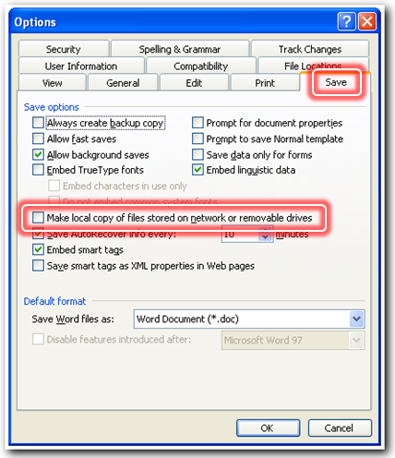
Un-tick Make local copy of files stored on network or removable drive.
Press OK.
Word 2007 and later
Open the Options dialog (see Opening the Options Dialog on page 89).
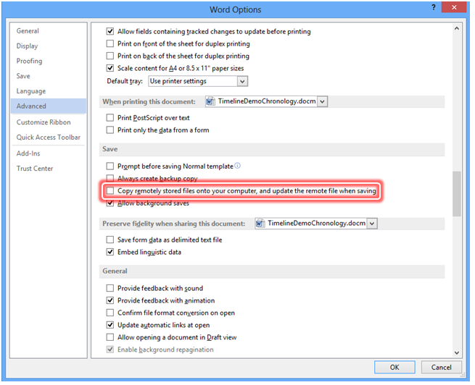
Press Advanced and scroll down to Save.
Un-tick Copy remotely stored files onto your computer, and update the remote file when saving.
Press OK.

5221 | Performance recommendation
 | Chronolator has set the option. Please close and re-open this document to allow it to take effect.
Further Information | See Message 5220.

5230 | Change tracking alert!
<document name> is using Word's Track Changes feature. Tracking changes can cause severe problems when processing tables.
Press OK to accept all tracked changes and turn change tracking off, or Cancel if you want to review them.
Further Information | Using Tracked Changes with tables can cause problems in any Word document, not just a Chronolator one. Microsoft are aware of this, but at the time of writing there is no fix on the horizon.

5231 | <process> cancelled - change tracking active
<document name> is using Word's Track Changes feature.
The Tracked Changes feature can cause severe problems when processing tables.
Further Information | The named <process> was cancelled because change tracking is active in the document <document name>.
Possible causes | You replied Cancel to Message 5230.  You replied OK to Message 5230, but Chronolator was unable to turn off tracked changes.
Suggested actions | Review the tracked changes if you wish, then retry the cancelled process and reply OK to Message 5230.

5232 | Unable to determine Tracked Changes status in <document name>
Chronolator could not determine whether Tracked Changes is on in the document because it appears to be locked by another user.
To be on the safe side, Chronolator will assume that Tracked Changes is on.
The Tracked Changes feature can cause severe problems when processing tables.
Possible causes | Someone else is editing the document and Chronolator could not determine whether Change Tracking is on.
Suggested actions | Close the document and wait for the other person to close it as well. Reopen the document.

5233 | Unable to turn off Tracked Changes in <document name>
Chronolator could not turn off Tracked Changes.
This is probably because the document has been protected.
The Tracked Changes feature can cause severe problems when processing tables.
Possible causes | <document name> has been protected so that the Tracked Changes feature cannot be turned off.
Suggested actions | Turn off the protection. You might need to supply a password.  The relevant protection feature can be found in various places:  - Word 2013 - the Track Changes dropdown or the Restrict Editing button on the REVIEW tab of the Ribbon;  - Word 2010 - the Restrict Editing button on the Review tab of the Ribbon;  - Word 2007 - the Protect Document dropdown on the Review tab of the Ribbon.

5300 | Open Web Tutorials?
Chronolator cannot find the Tutorials on your computer.
Press OK to go to the Web tutorials (requires an Internet connection).
Further Information | A full set of tutorials is maintained on the Web for non-licensees and for licensees who choose not to install them.
Possible causes | The Chronolator tutorials are not included in the standard installation packages.  It is unlikely that the tutorials will exist on computers belonging to non-licensees who receive Internal Chronologies.
Possible actions | Press OK if you are connected to the Internet and want to view the Web tutorials.

5310 | Web connection error
Chronolator cannot find the Tutorials on the Web.
If you are sure your connection is OK, please report the problem to us using the form on our website: www.chronolator.co.uk/bug_form.htm.
Further Information | The Web tutorials cannot be found.
Possible causes | You do not have an open Internet connection, or your organisation might have limited your access.
Possible actions | Connect to the Internet or contact your IT department to grant you access to our website as appropriate.  If your connection is open and unlimited, please report the problem using the form described in the message.

5320 | Cannot save the document using the name you chose
A document with that name is already open in Word.
Please try the save again using a different name.
Further Information | Word does not allow you to save a document with the same name as one which is already open.
Possible causes | You have tried to save a document using the same name as an open document.
Possible actions | Retry the save using a different name.

5321 | Cannot overwrite Chronolator system file
Saving the file using this name might overwrite documents which Chronolator needs to function.
Please try the save again using a different name.
Further Information | Chronolator will not let you save a file using one of its own reserved file names (ChronolatorMasterChronology and ChronolatorOnlineWorkbench).
Possible actions | Retry the save using a different name.

5322 | Permission Denied
You do not have Write access to the requested folder.
Please try to save the file in a different folder.
Further Information | You have tried to save the file in a folder to which you do not have Write access
Possible actions | Save the file in a folder to which you do have Write access, such as My Documents.  If you think you should have Write access to the folder, contact your IT department.

5323 | File name changed
Word has changed the file name since you last saved this document. If you are unaware of this change you might not be able to find the file after you close it.
After you press OK, you will be asked to save the document using a name of your choice.
Please refer to the manuals if you frequently get this message.
Further Information | You might have become a victim of a bug in Word.
Possible actions | Save the file in the right place with the right name.  If the message is issued often, please ask your Administrator to contact Berrick Computing, quoting Message 5323.

5400 | Internal inconsistencies in Chronolator document
Chronolator has found internal inconsistencies in this document, which are detailed below.
These may stop Chronolator functions working. Standard Word features are unaffected.
<list of inconsistencies>
Further Information | Information about the structure of a Chronolator Document is stored in document variables. Inconsistencies in this information might stop some Chronolator functions working. However, standard Word functions should not be affected.
Possible causes | The document is stored on a slow network.  Word might have ended abnormally when it last processed the document, causing internal inconsistencies.
Possible actions | If the document is on a slow network, close it and try opening it again. If that does not work, copy the document to your Desktop and work on that copy; remember to move it back to the network when you have finished.  If the document is indeed corrupted, open a valid Chronolator Document with the correct table headings (for example, the original document sent to you by an Administrator), and copy the contents of the problem document into it. Save this new document and use it from now on.

5402 | Unable to create table
Chronolator cannot create a new table in this document because of following internal inconsistencies in its structure:
<list of inconsistencies>
Further Information | See Message 5400 for suggestions about how to resolve these inconsistencies.

5403 | Unable to set styles
Chronolator could not set some document styles because the file appears to be locked by another user.
This will only affect the fonts used to display any error messages at the end of the document.
Further Information | If there are any error messages at the end of the document, they might not be displayed in the usual font.
Possible causes | Someone else is editing the document.
Suggested actions | Close the document and wait for the other person to close it as well. Reopen the document.

5500 | Clipboard Unavailable
Chronolator could not access the clipboard. Another application is probably using it.
Press OK to try again, or Cancel.

Messages 6000 - 6999
Chronolator issues these messages when an unexpected error occurs.

6000 | Unexpected processing error
Please note the information below and report it to us using the form on our website: www.chronolator.co.uk/bug_form.htm.
<problem description>
Further Information | Chronolator has encountered an unexpected error. The problem description provided will help diagnose the error.
Possible actions | Please note the problem description and what you were doing at the time and send the details to us using the form on the website. The more information you can provide the better. The Document Details and Word Environment reports will be useful if you can produce them after closing and reopening the document. See Document Details and Word Environment Reports on page 73.

Messages 7000 - 7999
Chronolator issues these messages when you use the Anonymisation and Highlighting features.

7000 | Glossary contains duplicated entries
Anonymisation and Personalisation are not possible because the Abbreviations Glossary contains duplicated abbreviations and / or duplicated definitions.
You can update the glossary and related text using Admin > Abbreviations.
Possible actions | See Changing an abbreviation on page 52.

7010 | Warning!
Formatting introduced while using the Anonymisation feature will be lost when Checking or Merging Tables. It is strongly recommended that you do not use this feature until you have no further need to Check or Merge tables.
Press OK to continue, or Cancel.
This message will not be shown again during this session.
Further Information | The Bold, Italic, Underline formatting which can be applied using the Anonymisation feature will be lost if you Check or Merge tables.
Possible actions | Ensure you have done all the error-checking and merging you require before using the Anonymisation feature.

7030 | Abbreviation Not Used
 | The selected abbreviation and definition are not used in the text.

7031 | Abbreviations Not Used
 | The selected abbreviations and definitions are not used in the text.

7032 | Nothing to anonymise
The selected abbreviation is not used in the text.
OR
The selected abbreviations are not used in the text.

7033 | Nothing to personalise
The selected abbreviation is not used in the text.
OR
The selected abbreviations are not used in the text.
Further Information | If the message includes the text ‘with the specified formatting’, you have asked Chronolator only to look for abbreviations which have Bold, Italic, Underline formatting by ticking the box on the Anonymisation form. See the comments about the Use formatting checkbox on page 56.

Messages 8000 - 8999
Chronolator issues these messages when you use Chronolator Add-ins.

8000 | Add-in loaded successfully
 | Please refer to the documentation accompanying the add-in for details about what it does and how to use it.

8010 | Add-in failed to load
<document>
<error message>
Further Information | Add-in <document> failed to load.  The reason is given in <error message>
Possible actions | Ensure that <document> is a valid Chronolator Add-in for the version of Chronolator.  If you think it is, contact your Administrator and ask them to report the problem to Berrick Computing. Give them as much detail as possible.

8020 | Cannot open document - a Chronolator Add-in is loaded
 | Only one Chronolator document can be open while a Chronolator Add-in is loaded.

Check Table Error Codes
These messages appear as Tooltips when the mouse is hovered over a table error, and are also listed at the bottom of a Chronolator Document after Check Tables discovers errors.

c8n100 | This row contained the wrong number of columns. Chronolator has rectified this, but you should check that the each entry is under the right heading
Further Information | The number of columns in this row was different from the number of column headings. Chronolator has added or deleted columns to rectify this. No data will have been deleted, but it might not be in the correct column.
Possible actions | Review where Chronolator has put the original data, and move it into another column if necessary.

c8n120 | This column is blank, but must always be completed. Add some text.
Further Information | The Case Review Administrator has deemed it mandatory that this column should always be completed.
Possible actions | Add text to the column.

c8n125 | 'As Above', 'See Above', or ditto marks are not allowed.
Further Information | This can seem annoying when you are entering many similar events into an Internal Chronology. However, remember that the Administrator will probably merge your chronology with others. When merged chronologies are sorted, ‘As Above’ and similar rows may well become separated from their previous predecessors.
Possible actions | Copy and paste text from the previous row.

c8n130 | Cell is vertically merged. Copy any text to another row or rows and delete all rows containing this cell.
Further Information | The table cell in question spans more than one row; this is called a ‘vertically merged cell’. Chronolator is unable to process tables containing vertically merged cells.
Possible actions | Insert one or more rows. Copy and paste any required text, then delete all rows containing the problem cell.

c8n135 | Cell contains a nested table. Convert the nested table to text.
Further Information | The table cell in question contains a nested table. This can happen if you select the relevant option when pasting from on table into another.
Possible actions | Convert the nested table to text, and make sure the information it contains is under the correct column headings.

c8n140 | The '>' character is not allowed in this column.
Further Information | Chronolator uses the ‘>’ character to keep track of the Source of Information in a Composite Chronology. It is, therefore, not allowed in an Internal Chronology.
Possible actions | Use a different character.

c8n145 | Invalid Source
Further Information | The Source of Information column contains an invalid Source Prefix. Source Prefixes are assigned when you import a chronology document and cannot be changed afterwards.
Possible actions | Press Admin > Show Document Details to see the list of prefixes which are valid in this document.

c8n210 | Invalid date, or invalid date format. Try another format (e.g. '01 feb 2006' or '01.02.06').
Further Information | Chronolator cannot interpret the date in this cell. It might be in a recognisable format but be invalid (e.g. ‘32 May 2007’), or Chronolator might not recognise the format.
Possible actions | Enter a date in a recognisable format. Chronolator recognises most common date formats.

c8n220 | Invalid time, or invalid time format. Try another format (e.g. '1.20 am', '0120', or '01.20').
Further Information | Chronolator cannot interpret the time in this cell. It might be in a recognisable format but be invalid (e.g. ’25:00’), or Chronolator might not recognise the format.
Possible actions | Enter a time in a recognisable format. The message text indicates a number of formats that Chronolator recognises.

c8n230 | Event ends before it starts.
Further Information | None.
Possible actions | Change the start or end dates / times of the event.

c8n240 | Start of event is out of sequence.
Further Information | None.
Possible actions | Check the information about when the event started. If it is correct, you can use the Sort Tables button to put the event in the proper place in the table.

c8n250 | End of event is out of sequence.
Further Information | None.
Possible actions | Check the information about when the event finished. If it is correct, you can use the Sort Tables button to put the event in the proper place in the table.

c8n300 | At least one abbreviation is not defined. Change the abbreviation, or use the Admin > Abbreviations > Define button to define a new one. Put multiple abbreviations on separate lines, or separate them with commas.
Further Information | None.
Possible actions | As suggested in the note.

Appendix C – Licensing
Chronolator is licensed software. You can evaluate its features without having a licence, but the documents it creates include a watermark on every page. If you do not want these watermarks to appear, Chronolator must be licensed.
When you open the first Chronolator Document in a particular Microsoft Word session, a form is displayed where you can accept or decline the licence terms. The Licensee and Expiry Date are shown on the form, and the full terms of the licence can be displayed by pressing the View Licence button. If you do not accept them, the document will close.
Chronolator Documents and the Chronolator Online Workbench are licensed in different ways.

Online Workbench Licence
When you buy a licence to use the Chronolator Online Workbench, you are given a small file whose name begins Chronolator3Licence.
The licence is specific to a particular purchaser, and the licence file should not be distributed to anyone else except as allowed in the licence terms.
Details about how to get a licence for the Online Workbench can be found on the Chronolator Web site at www.chronolator.co.uk/licence.htm.
To install the licence, copy it into the same folder as the Online Workbench. The Online Workbench propagates the licence information into the Chronolator Documents it creates.

Chronolator Document Licence
Chronolator Document licences are created by the Online Workbench and stored internally in the Chronolator Document.

Licence Period
A Chronolator licence is valid for a specified period.
- For the Online Workbench, the period is contained in the licence file;
- Internal Chronologies are licensed for four calendar months from the day they are created;
- Composite Chronologies created by the Online Workbench are licensed for the same period as the Online Workbench;
- Composite Chronologies created by Local Administrators using the facilities included in an Internal Chronology expire at the same time as that Internal Chronology.

What happens when a licence expires
When a licence expires, all the standard Microsoft Word features continue to function, but the Chronolator toolbar and buttons do not appear, and no Chronolator features are available.
Chronolator Documents whose licence has expired can be imported into licensed Composite Chronologies as if they were still licensed.

Temporary Licence Extension
Unavailability of records and other factors can sometimes delay the completion of a Chronolator Document beyond its expiry date. Chronolator Documents therefore provide a simple means to extend a licence without having to contact Berrick Computing Ltd.
For 90 days after a Chronolator Document expires, an Extend Licence button appears on the Licence Acceptance form. Pressing it extends the licence for 30 days. Only one such extension can be made, so you should not do this until you know you can complete the chronology within those 30 days.

‘Refreshing’ an expired licence
If a Chronolator Document has exceeded the temporary licence renewal threshold, the Case Review Administrator should create a new blank one with the correct column headings. Having done so, the contents of the expired document can be incorporated into the new one using Word’s standard Insert File feature. Details of how to use it are in Step 2 of the ‘Recovering corrupted Chronolator Documents’ section on page 97.

Appendix D - How Chronolator deals with events with imprecise dates or times
In the real world, events begin and end on exact dates and at exact times. In a chronology, not all this information might be known for a particular event. Indeed, in some chronologies, the administrator might decide not to collect some of this information at all.
Chronolator always ensures that the Start Date of event is specified, but the Start Time, End Date and End Time are often missing. How does it deal with such events?

Assumptions

Individual events
When information about the exact start or end of an event is missing, Chronolator makes the following assumptions so that it can be processed.
- If Start Time is missing, it is assumed to be midnight (00:00);
- If End Date is missing, it is assumed to be the same as Start Date;
- If End Time is missing, it is assumed to be the same as Start Time.

Durations
Sometimes the elapsed time between two instants needs to be calculated; for example, the interval between two events, or between the start and end of a single event. Chronolator assumes that any information missing in the later instant is the same as that of the earlier one.

Assumed information is never displayed
Whatever assumptions Chronolator might make about missing information, it will never display those assumptions explicitly. For example:
- an event which Chronolator assumes to start at midnight, for example, will never include that time in any display;
- a duration based upon an assumed time will only include date-based information.

Overriding Chronolator’s assumptions
Sometimes you might know the order in which events happen even though you do not know their dates and time exactly. In these circumstances you can use a Sequence column to ensure that Chronolator sorts events in the order you specify. The Check Tables button can still be used to check that such ‘manually’ sorted events are in a valid order. For more information about the Sequence column, see Using a Sequence column on page 59.

Appendix E - Chronolator Terminology

Term | Meaning
Chronolator Document  Chronology Document | A document containing one or more tables created by Chronolator.
Internal Chronology | A Chronolator Document specific to a particular organisation or department.
Composite Chronology | A Chronolator Document containing information from two or more Internal Chronologies.
Case Review Administrator | Someone who sets up Chronology Documents using the Online Workbench.
Local Administrator | Someone who distributes an Internal Chronology for others to complete and then merges the results into a Composite Chronology.
Online Workbench | Used by a Case Review Administrator to create and manage Chronolator Chronology documents.

An Internal Chronology contains events from a single organisation or department
A Composite Chronology contains events from more than one organisation or department
this only happens once in a particular Microsoft Word session.
Usually only one.
Chronolator always formats the chronology table with the Normal style. If you want to ensure that changes you make to the font are preserved during Chronolator processing, you should update the Normal style. Refer to Word Help for more information about formatting a document with styles.
taken from SampleTableWithErrors.docm in the Samples folder
Using the Online Workbench to create the Composite Chronology ensures that it is licensed for as long as the Online Workbench. Composite Chronologies created from an Internal Chronology are only licensed for the same period as the Internal Chronology.
There should only be one, but it is possible that someone might inadvertently have created more. Chronolator will copy all tables which match the Case Details set by the Case Review Administrator.
International Standards Organization
See Setting up Chronolator Documents for details about how to do this
So do the Trusted Publisher and Trusted App Catalogs buttons, but they are not relevant to Chronolator Documents
This might change when the first Service Pack of Word 2013 is released.
If the document contains multiple tables, the message heading will be “Tables merged and sorted” or “Tables sorted individually” according to the response to Message 1120.
If the document contains multiple tables, the message heading will be “Tables merged and sorted” or “Tables sorted individually” according to the response to Message 1120.
Internal Chronologies created by Berrick Computing Ltd under the terms of a Single Case licence are licensed for the period agreed with the purchaser

