About this Document
Applies to Chronolator Version | 3.5
Document version | 3.5.01
Purpose | After you have downloaded and unzipped Chronolator as described at www.chronolator.co.uk/downloads/download-complete.htm you can use the procedure below to check the installation of the Chronolator Online Workbench.

Verifying Chronolator Online Workbench installation
Action | Expect
Go to the ChronologySetup folder and open ChronolatorOnlineWorkbench.docm, ensuring macros are enabled. | One of the displays below will show the status of your licence.
If you have not yet installed a licence in the ChronologySetup folder, or you have done but there is a problem with it, the Evaluation Licence will be displayed like this: | 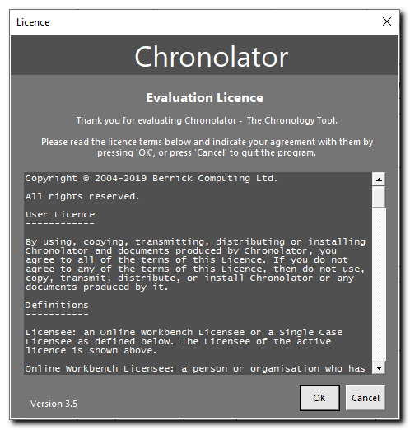
If you have correctly installed a Chronolator licence in the ChronologySetup folder, it will display the licensee, expiry date, and reference like this: | 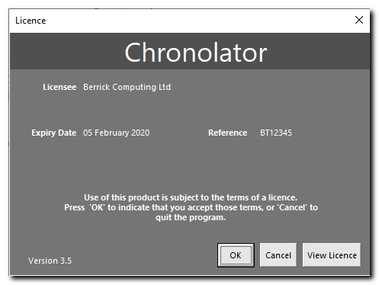
Press OK. | The Online Workbench will open.
Check the Chronolator toolbar is present. | The location of the toolbar varies depending on your Word version. It is described in the Online Workbench text.
Press New Internal Chronology on the Chronolator toolbar | The Case Details wizard is displayed:  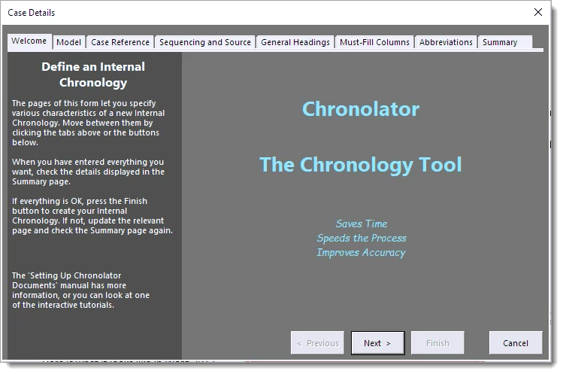
Click on the Summary tab of the wizard and press Finish | 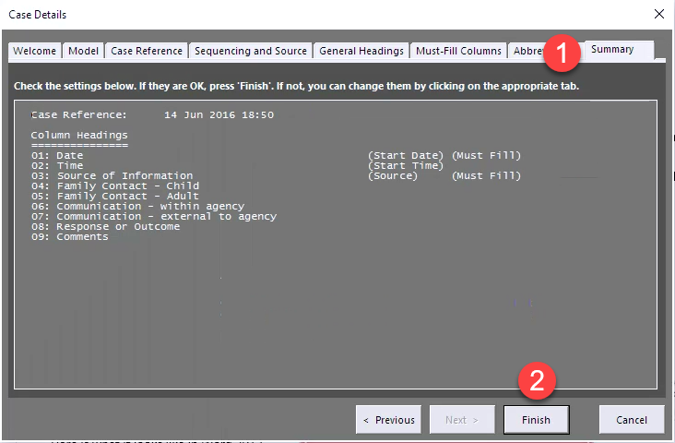  Word prompts for a filename and location for the new chronology document.
Choose a name and location and save the document. | A new document is created.
Close all documents. | This completes the Installation Verification Procedure.

